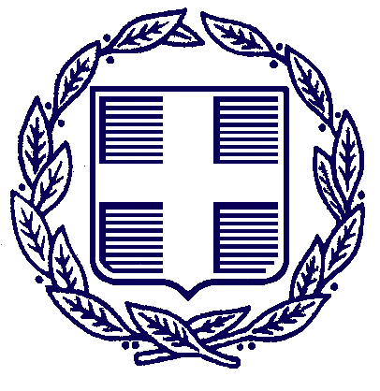
HELLENIC REPUBLIC
MINISTRY FOR ECONOMY,
INFRASTRUCTURE, SHIPPING AND TOURISM
29/06/2015
PRESS RELEASE

Τhe Ministry for Economy, Infrastructure, Shipping and Tourism would like to inform visitors to Greece that capital controls introduced by the Greek Government do not apply to those wishing to withdraw money from an ATM or carry out any other type of transaction using credit or debit cards issued abroad.
Moreover, the Ministry does not expect any inconvenience in visitor’s every day holiday experience, neither in the islands nor in mainland Greece, as there are adequate fuel supplies, products and services.
Greece continues to offer the highest quality of tourism services to its visitors, who have ranked Greece as one of the best destinations worldwide.
The Deputy Minister for Tourism, Mrs Elena Kountoura, said that Greece still is and will always be a favourite destination for holidaymakers. Visitors currently in Greece as well as people planning to visit Greece will not be affected by the latest developments and they can continue to enjoy their holidays in Greece without any problems whatsoever.

