An Insight Guide of Prespa Lakes Region

Short description of the region

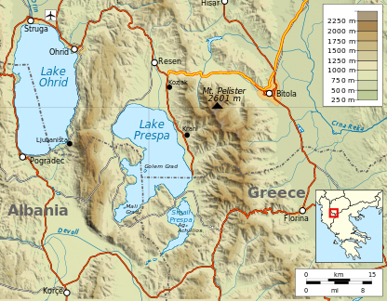
Located in the north-western corner of Greece at 850 metres above sea level and surrounded by mountains, the Prespa Lakes region is a natural park of great significance due to its biodiversity and endemic species. Prespa is a trans boundary park shared between Greece, Albania and FYR Macedonia.
It only takes a few moments for the receptive visitor to see that they have arrived at a place with its own unique personality. Prespa is for those who love nature and outdoor activities all year round. This is a place to be appreciated with all the senses, as if it had been designed to draw us in, and remind us that we, too, are a part of nature.
Prespa is a place where nature, art and history come together in and around the Mikri and Megali Prespa lakes; there are also villages with hospitable inhabitants, always worth a stop on the way to listen to their stories and the histories of the place.
The lucky visitor might share in the activities of local people’s daily life, which are all closely connected to the seasons of the year. These activities have, to a large extent, shaped the life in Prespa. The three main traditional occupations in the region are agriculture, animal husbandry and fishing.
There are a lot of paths, guiding you into the heart of nature; perhaps up into the high mountains, or to old abandoned villages, which little by little are being returned once more to nature’s embrace.
Visitors to Prespa should be aware of the importance of the natural environment in the region. They can help to guard the area’s natural resources and keep a clean and sustainable ecosystem in Prespa, so that when they return to this little corner of the world it impresses them as much as the first time; because in Prespa, it is always the first time.
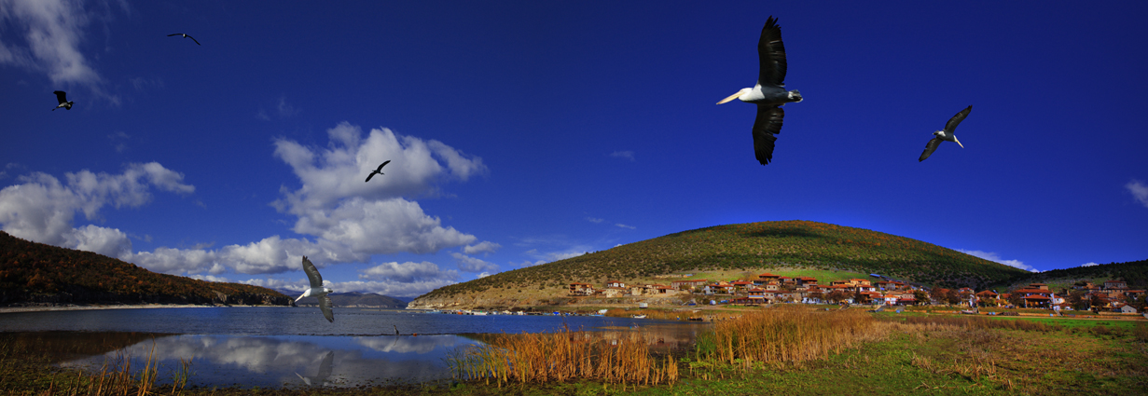

Places to visit
Villages
Agios Achilleios
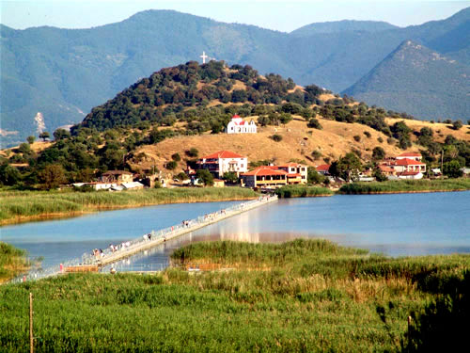
Description: Agios Achillios is the only village on the only inhabited island in the Prespa lakes, from which it takes its name. Cars are not allowed to enter on the island, so to arrive in the village you must cross a pedestrian 850m long bridge. This traditional fishing village is also home to an endemic species of small cows. And, according to local tradition, if one more house is built in the village, all the houses will fall down! Because the island is located in the middle of the basin, the village is also a good place to get a 360 degree panorama of the entire Prespa basin.
Population: 27 inhabitants.
Don't miss:
- A walk around the island and bird watching (look for the cormorants and pelicans) from the pedestrian bridge
- The monastery of Panayia Porphyra
- The basilica of Agios Achillios
Agios Germanos
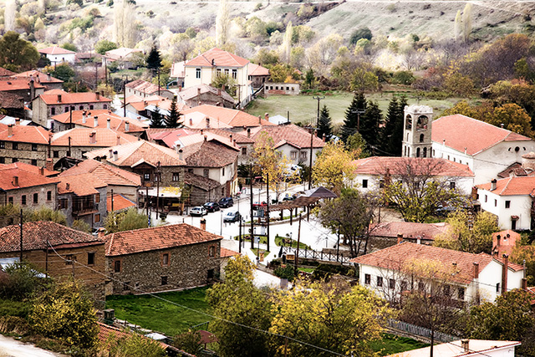
Description: Agios Germanos is located at the west end of a valley at the foot of Varnoundas Mountain (Mt.) at the borders with FYR Macedonia. A stream with the same name cuts through the village and flows into the Megali Prespa Lake. Agios Germanos is best known for the traditional architecture (stone) of its houses.
Population: 230 inhabitants.
Don't miss:
- Panigiri on the 11th and 12th of May
- The church of Agios Germanos (end of the 10th century)
- The information center of the Prespa National Park Management Body on the square, which can provide you with information about the whole Prespa Region
Antartiko
Description: Antartiko is one of the few villages in the Prespa Region with no view of the lakes. It is located at the foot of Vernon Mt. and is crossed by the Ladhopotamos River. It is one of the villages most affected by the rural desertification due to the Greek civil war that followed World War II. The number of inhabitants declined from 3,000 to 150-180. But many old houses are still proof of the importance of the village before the war. The architecture, a combination of stone and mud-brick, is very characteristic of the region.
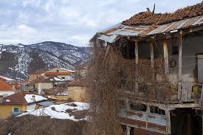
Population: 165 inhabitants.
Location: see map.
Don't miss:
- Panigiri on the 12th of June
- The church of Agios Athanasios
- The church of Agios Nikolaos

Kallithea
Description: Kallithea is located at the foot of Varnoundas Mt. This village has one of the most beautiful views of Prespa Lake, as its name implies (Kalli = nice; Thea = view). Kallithea is a cattle breeding village. It is surrounded by a dense forest of exceptional beauty and is criss-crossed by paths leading up the mountain, where the panoramic view of the Prespa basin becomes more breathtaking with every step.
Population: 160 inhabitants.
Don't miss:
- The church of Agios Athanasios and its view of the lake
- Panigiri on the 26th of July
- The church of Agios Georgios great view of the lakes
Karies
Description: Located on a plain close to Seltsa, an area with valuable natural resources such as endemic flora.
Population: 100 inhabitants.
Don't miss:
- A walk on the mountain above Karies
- The church of Analipsis (closed)
- Panigiri on the 1st June
Kottas
The village of Kottas is the birthplace of Captain Kottas (1863-1905), one of the earliest protagonists of the Greek Struggle for Macedonia.
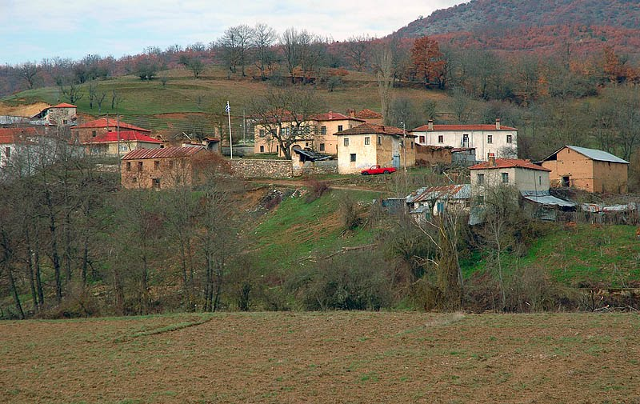
Population: almost 30 people.
Don't miss:
- Museum of Kapetan Kottas
- House of Kapetan Kottas
- Museum of Macedonian race
- Very beautiful routes
Krystallopigi
Krystallopigi means "crystal source". The village is located right at the border crossing with Albania.
Population: 200 people.
Don't miss:
- Very beautiful routes
- Panigiri during the second week of August
- Valley of Ladopotamos

Laimos and Milionas
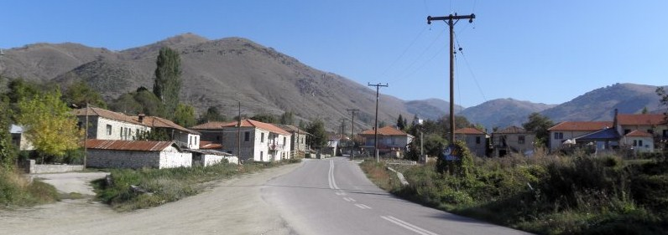
Description: Laimos is the main village in Prespa and is the region’s administrative center. Laimos is located at the narrowest point in the valley – Laimos means “neck” in Greek – and is divided in two by the Agios Germanos stream. Milionas is an almost abandoned village which is very close to Laimos. It is used by locals to stable and graze their cattle. Two couples from Athens purchased old houses which they are currently renovating.

Population: 300 inhabitants.
Don't miss:
- The Byzantine church of Hypapandi (closed)
- A walk around the village in the evening, when people meet to talk
- A walk to Milionas
- Panigiri on the 24th of June
Lefkona
Description: Lefkona is located on the biggest plain in Prespa. From Lefkona you can walk up to Kale hill and enjoy the peaceful and panoramic view of the place. Lefkona is surrounded by bean fields in summer.
Population: 155 inhabitants.
Don't miss:
- Panigiri on the 26th of October
- Walk up Kale hill
- Gun emplacement from 2nd war
- Different routes in the mountain called Varnountas

Microlimni
Description: This traditional fishing village is located at the shore of Mikri Prespa Lake. It is surrounded by several hiking trails and areas that are highly protected due to their great natural value. From this village you can go to Latsita valley, a good place to relax and breathe in the purity of nature and, in season, watch birds. If you walk farther across Latsita into the mountains you will find the abandoned village of Kranies.
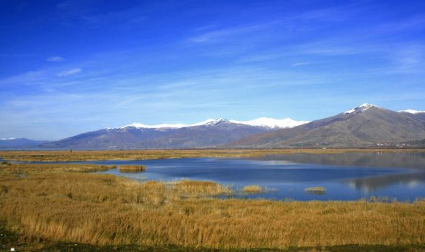

Population: 50 inhabitants.
Don't miss:
- The traditional Prespa boat
- Latsita valley
- The church of Agia Paraskevi
Oxia
Description: Oxia is a small village close to Microlimni; with a horse stable. From Oxia you can hike to Sfika, an abandoned village on Triklario Mt.
Population: 20 inhabitants.
Don't miss:
- The abandoned village of Sfika up in the mountains
- The church of Agios Athanasios
Pili
Description: Pili is located at the shore of Mikri Prespa Lake at the foot of Devas Mt. From Pili you can go to the abandoned village of Daseri, around 3 km away, and to Zachariade’s cave, used by the partisans during the Greek civil war. Surrounded by bean fields, Pili is a quiet village, nestled between forest and lake.
Population: 120 inhabitants.
Don't miss:
- The cave of the partisans
- The small church of Agios Nikolaou
- A visit to Daseri, an abandoned village, a place of tranquillity and beauty. Only a few ruins remain; the best preserved building is the school. From here, you can get a close view of Vidhronisi Island.
Pisoderi
Description: Pisoderi is located on a very steep slope of Vernon Mt., close to the ski resort of Vigla. From Vigla, a path leads you to Agios Germanos across the top of Varnoundas Mt.
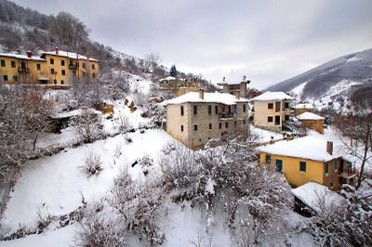
Population: 70 inhabitants.
Location: see map.
Don’t miss:
- Nearest village to Vigla-Sky station
- Traditional architecture
- The monastery of Agia Triada

Plati
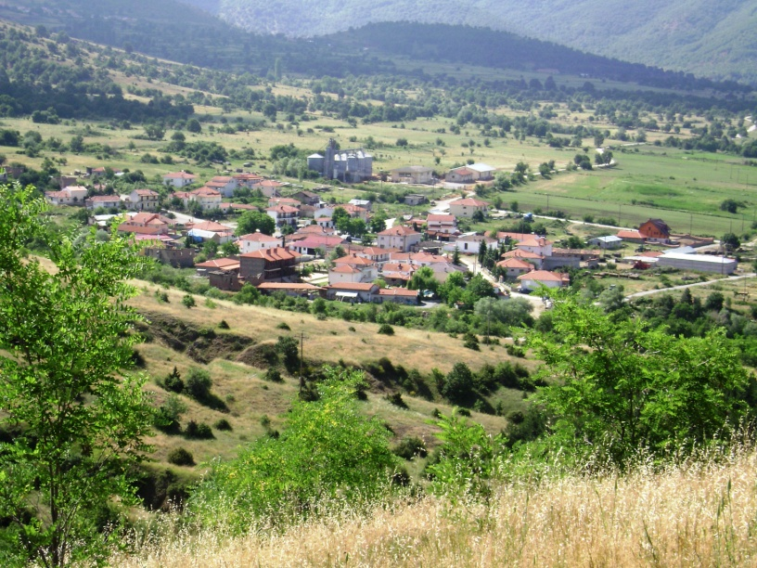
Description: Plati is located on the biggest plain in Prespa. The village is crossed by the Platiotiko stream. From Plati there is a fine, expansive view of Mikri Prespa Lake. You can also visit the permanent exhibition of old artefacts and tools.
Population: 110 inhabitants.
Don't miss:
- Church of Agios Nikolaos –Ayia Sotira (closed)
- The exhibition of old Prespa artefacts and tools in the hotel Platythea
- Panigiri on the 5th and 6th August

Prasino
Population: 1 inhabitant in the old village and 14 moved to the main road.
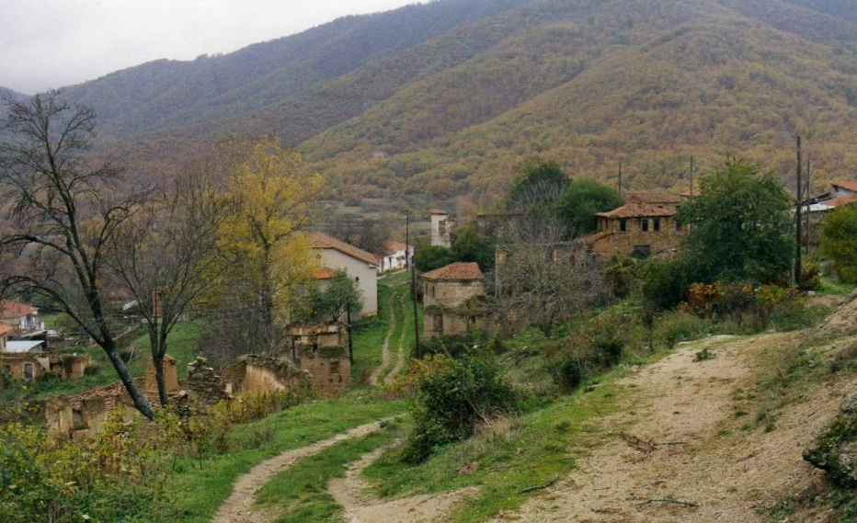
Psarades
Description: Psarades is located on the shore of Megali Prespa Lake. As its name indicates – Psaras means “fish” – it is a traditional fishing village. From Psarades you can take a boat trip to see the post-Byzantine frescos on the rocks and the hermitages built on the cliffs of the lake.
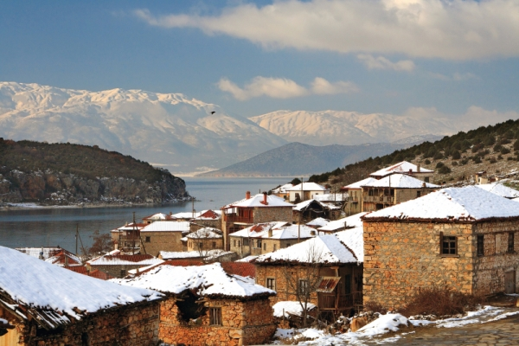
Population: 160 inhabitants.
Don't miss:
- A walk around the village
- A boat trip to the hermitages and frescos on the rocks
- In summer, a swim in the warm waters of the lake

Trigono
Description: Trigono is a small village located at the Florina-Prespa-Kastoria road junction at the foot of Vernon Mt. ‘Trigono” means “triangle” in Greek and the village took its name from the shape of it. The village was originally settled farther up the mountain and, in fact, moved twice to lower land until finally settling at its current location. Remains from the previous settlements can still be seen on the mountain.
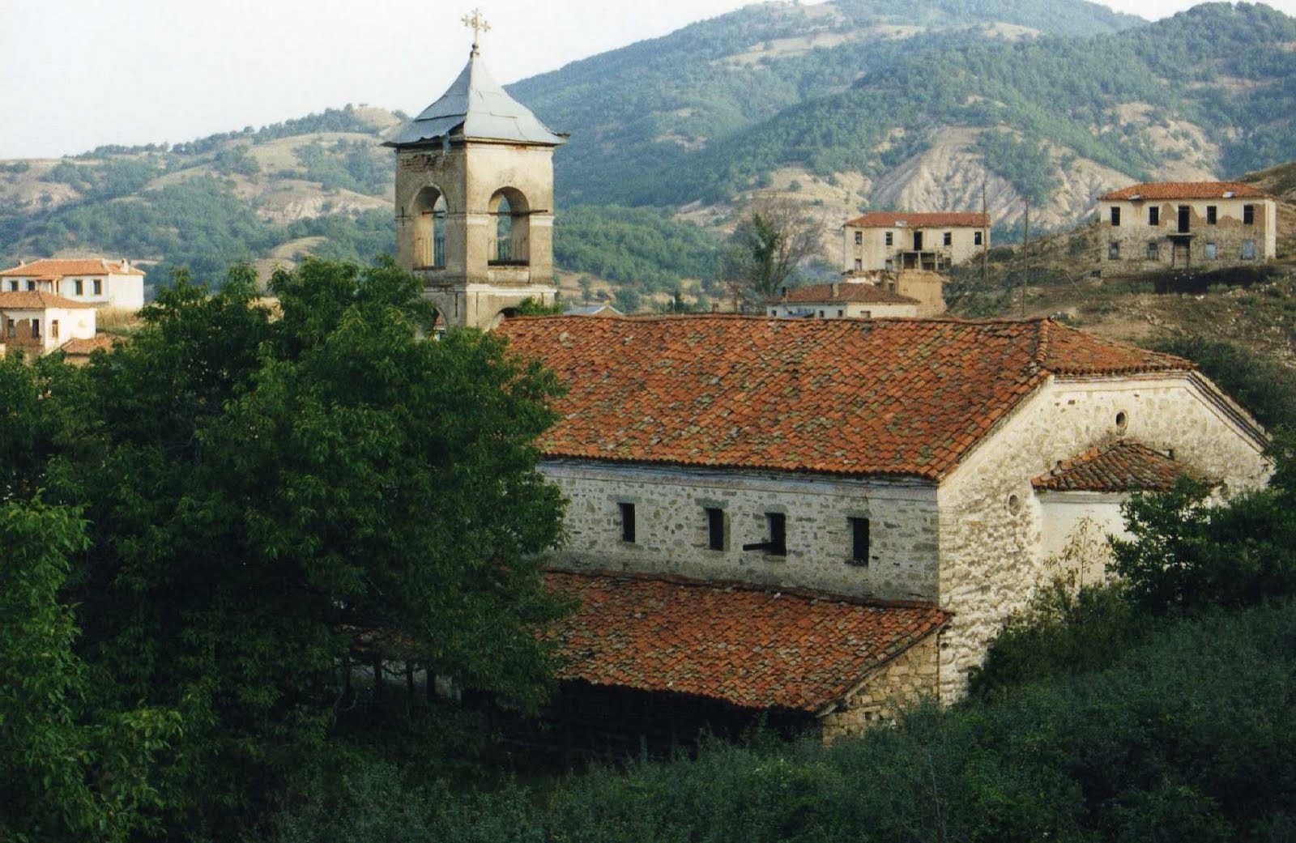
Population: 30 inhabitants.
Don't miss:
- The traditional architecture (mud-bricks)
- The church of Profithis Ilias (1920) located in the middle of the forest (ask for the keys from Antonis Papadopoulos on the square of the village: Phone 23850-45985)
- The church of Agios Nikolaou, 1866

Vatoxori
Description: Vatochori is a very small village and it was created from scattered settlements of farmers and pastoralists.
Population: 10 people.
Don't miss:
- The old primary school that feasts a folklore collection
- The church of Agios Nikolaos
- Very beautiful routes that goes to the villages Oxia and Mikrolimni
Vrondero
Description: Located at the foot of Vrondero Mt. on the border with Albania, Vrondero is one the few villages in Prespa without a view of the lakes. From Vrondero you can visit the abandoned village of Angathoto and the cave used as an improvised hospital during the Greek civil war. Vrondero is mainly a farming village close to the ruins of Pyxos ruins, an old human settlement.
Population: 180 inhabitants.
Don't miss:
- The small museum with fossils and coins located on the village square.
- The cave used as a hospital during the civil war
- Pyxos ruins

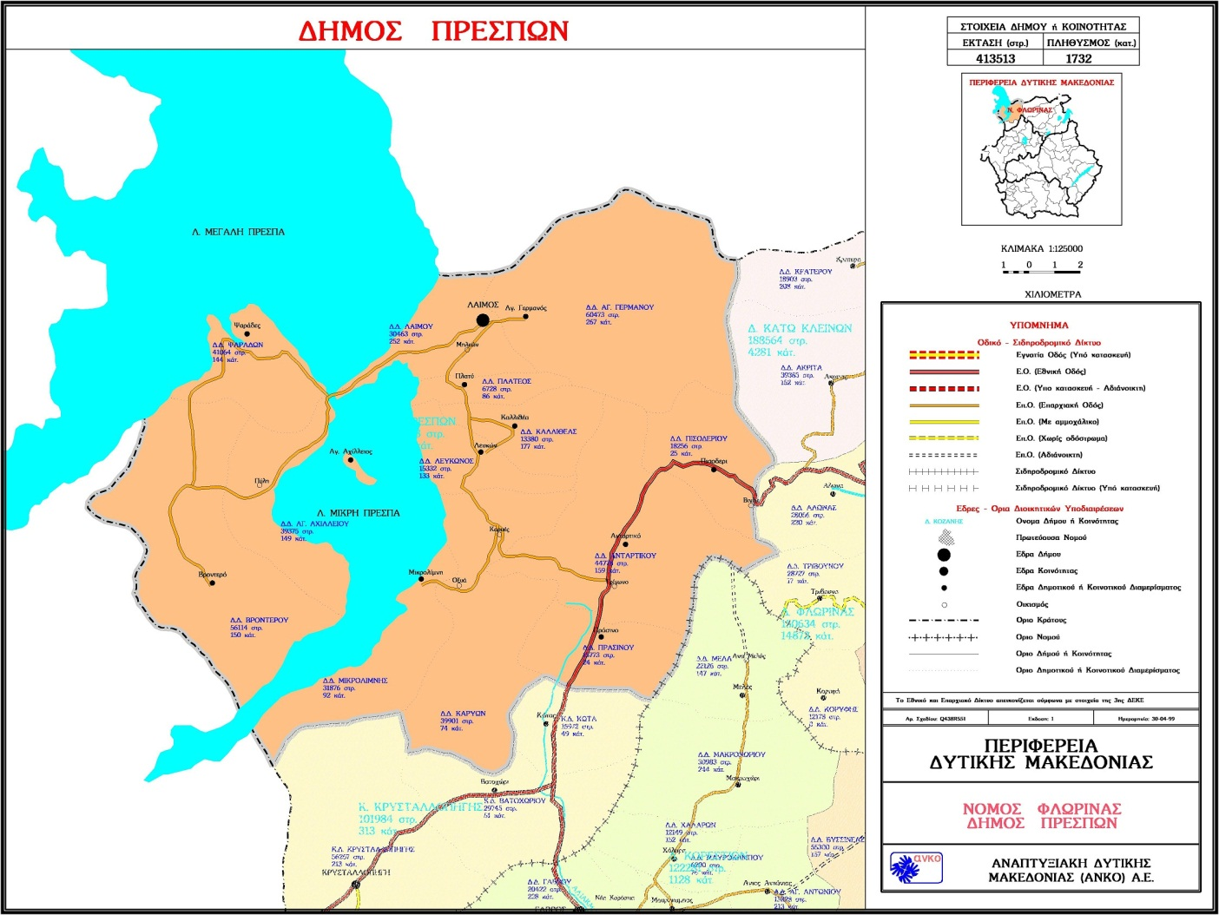
Map of Prespa’s villages
Churches

Most of the churches, basilicas and monasteries found in Prespa correspond to Byzantine and post-Byzantine styles. Even though some churches are not open to the public, you can still admire their external architecture.
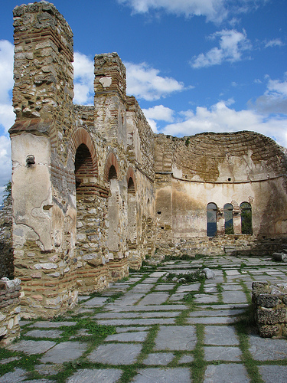
- Church of Agios Germanos
(11th c.)
- Church of Agios Athanasios
(end of the 18th c.)
Both located in the village of Agios Germanos. They are known especially for their well-preserved frescos.
- Basilica of Agios Achilleios
(976-1014 AD)
Located on the island of Agios Achilleios in the Small Prespa lake. It is an example of the survival of Early Christian architectural style in the Byzantine period.

- Ruins of the Church of the 12 Apostles
(11th c.- 12th c)
- Church of Agios Georgios
(End of the 15th c), Church of Agios Dimitrios, ruined Monastery of Panagia Porphyra (mid 16th c.). Basilica of Agios Achilleios
All located on the island of Agios Achilleios.
- Ruins of Agios Nikolaos in Pili

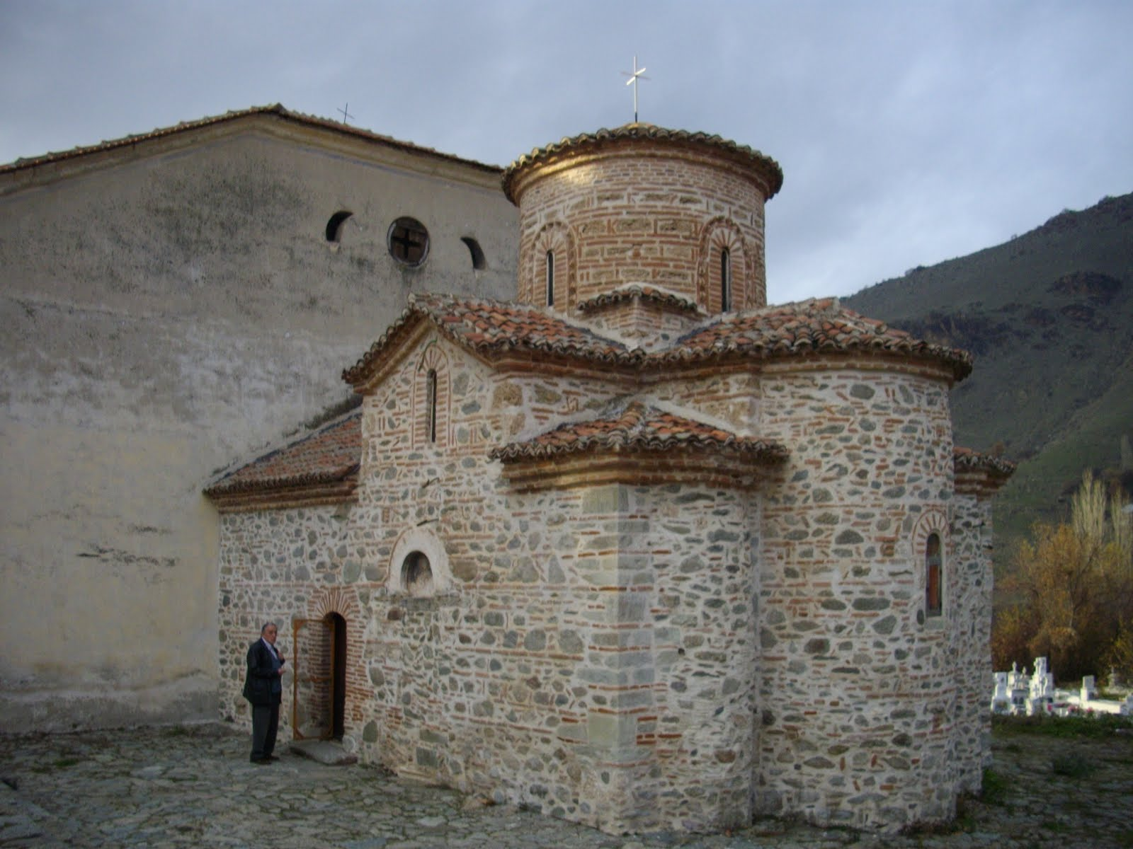

Church of Agios Germanos

The hermitages and frescoes

Frescoes can be found in Prespa either inside churches and hermitages or on the cliffs near the hermitages. These last ones can easily be seen during a boat trip on Great Prespa Lake, which can be arranged in the village of Psarades.

Hermitage of Panagia Eleousa

(Beginning of the 15th c.). It is the largest hermitage, which housed the largest number of monks. Frescoes in its interior are a particular example of the painting produced in this corner of the Great Prespa Lake.

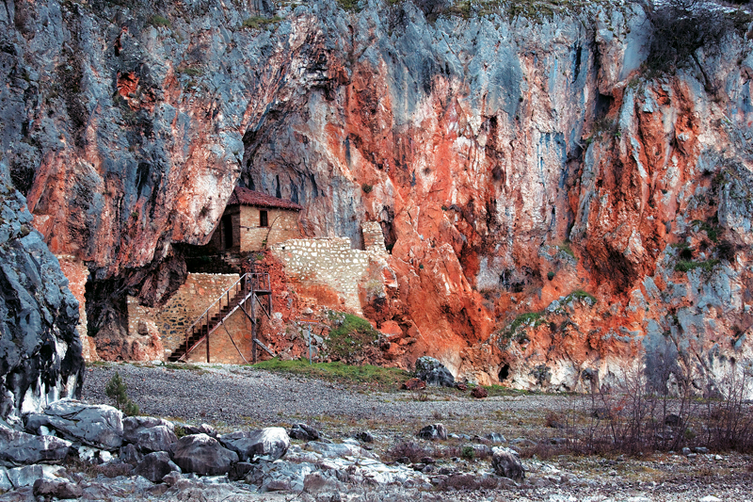
Hermitage of the Metamorphosis

(13th c.). Leaving Psarades in a boat for the hermitage of Panagia Eleousa, we pass a small stretch of shore with a bay where the hermitage of the Metamorphosis stands, protected by the rocks.

Hermitage of the Mikri Analipsis

(15th c.). The second hermitage we meet along the lakeshore after the frescoes on the rocks is that of the Mikri Analipsis. It is high up in a small cavity in the rock and it is difficult to approach. Metamorfosis
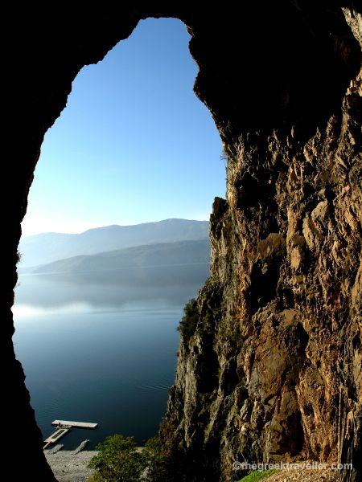

Panagia of Eleousa
Panoramas

Above the village Agios Germanos

Location: Near the small church close to the ‘potistra (watering place)’ behind Agios Germanos on the small hill of Isvoro (Mt. Moutsara) in Agios Germanos.
Best times: In the evening for the sunset and early in the morning for the best colors.
Best view:
The two lakes in a view as you walk up to the mountain.
How to access: This is an easy-going path which lasts one hour starting from the village of Agios Germanos
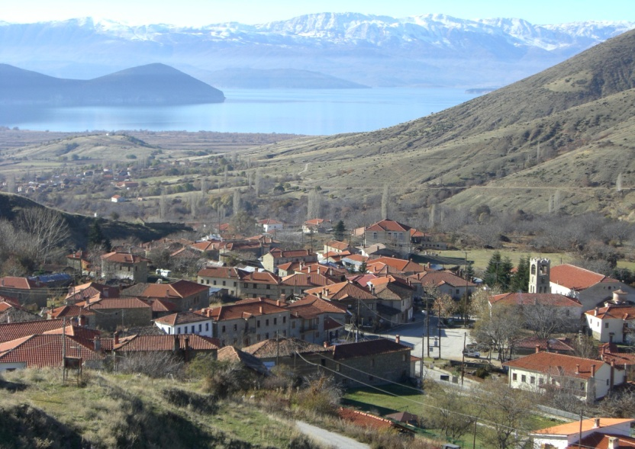

Kale
Location: On the top of the small Kale hill, close to the shore of Mikri Prespa Lake and close to the village of Lefkona.
Best times: During sunset and sunrise.
Best views: Midway along the path, there is a view of Agios Achillios Island. From the top, there is a panoramic view of Mikri Prespa Lake.
How to access: By car to reach the beginning of the path.
Description: This short, spiralling path, which only takes about 15 minutes to walk, can be easily enjoyed by the entire family.

Ruins of abandoned villages

The ruins of abandoned villages are a good opportunity for visitors to walk and discover the lesser-known and more peaceful places in Prespa, hidden in the mountains.
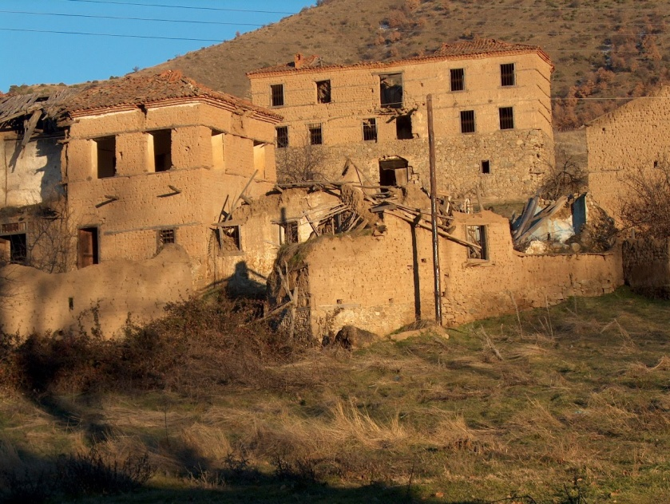
- The easiest to reach is Daseri, near Pili. There is left only the wall of the school and the stone bases of the houses remain.

- In Agathoto you can find the remains of a small church, hidden behind rocks and trees.

- Almost nothing remains of the Latsista settlement, situated amongst the small hills behind Mikrolimni. It is an ideal place for bird watching, due to the wetlands found there. Krania is situated a few kilometres further on. Only a few houses remain there. On the way there you can enjoy a unique view of the lake.

- Sfika, in the mountains above Oxia was once quite a large village as we can see from the size of the church, where only one fresco remains. The church is hidden in the forest and it is a delightful surprise to discover it so far from any inhabited area.

Prespa Nature
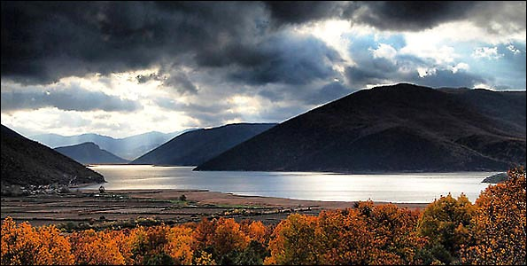

FLORA AND FAUNA: The large number of fauna and flora species found within a relatively small area, places Prespa among the most important protected areas in the world. Many flora and fauna species are rare and protected by international, European and national legislation.

Prespa is among the ten most important areas of the Mediterranean for its freshwater fish. Eight of the eleven fish species in the area are endemic. The twenty-two reptile species of Prespa comprise tortoises and freshwater turtles, lizards, snakes and vipers. More than forty-five species of mammals live in Prespa, including bats, wood mice, squirrels, hedgehogs, badgers, wild boars, foxes, wild cats and the four rarest land mammals in Europe: the wolf, the brown bear, the otter and the chamois. The Centaurea prespana is a distinctive endemic plant of Prespa.

The Birds

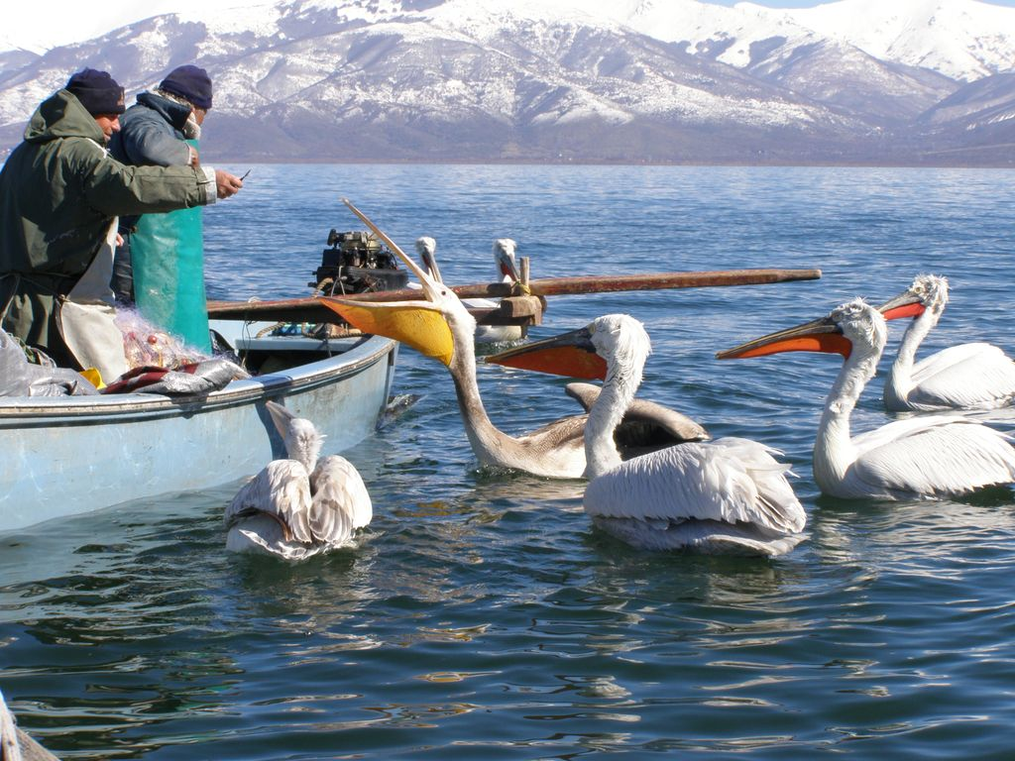
In Prespa more than 260 bird species have been recorded to date, of which approximately 140 nest here. Many of these species are rare and threatened with extinction.
The Dalmatian and Great White Pelicans are identified with the image of Prespa.
Pygmy Cormorants are the smallest and most rare of the three species of cormorants found in Europe.
The Great White Egret is the largest of the seven herons encountered in Prespa.

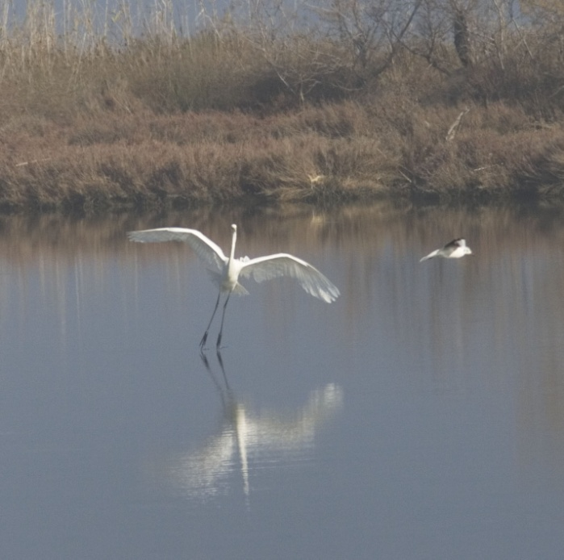

The Glossy Ibis is a distinctive species of the wet meadows.
In 2005 it began to nest in Prespa again, following the restoration of the wet meadows, which was carried out by the Society for the Protection of Prespa.
The Greylag Geese nesting in Prespa represent the last breeding population in Greece.

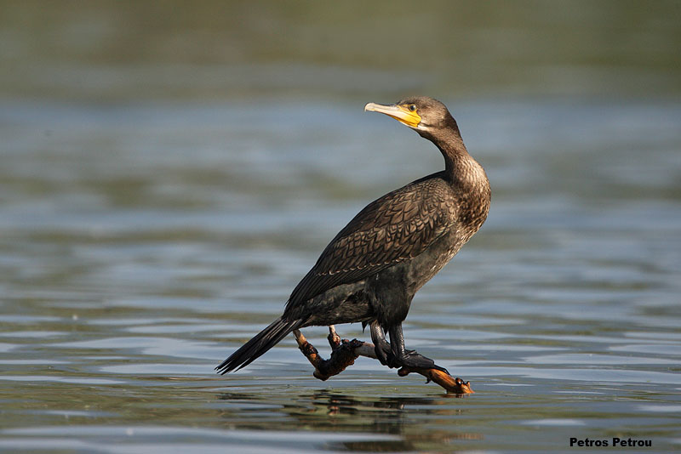
Trails
Pili–Daseri

Location: From Pili to the abandoned village of Daseri along the shore of lake Mikri Prespa.
Best view: When you reach Daseri. From there you get a panoramic view of the two islands on the lake and on a clear day you can see all the villages from Mikrolimni (right) to Agios Germanos (left, on the mountain).
How to get there: You can reach Pili by car and once there, turn left off the main road at the end of the village coming from Achios Achillios. You can park there and continue on foot.
Description: At first the path passes through bean fields and then along the base of the hills close to the shore. It is around one hour from Pili to Daseri. When you reach Daseri you find four old ruined buildings; the one on the right of the path, highest up the hill, was the village school. You can continue a bit further or turn back to Pili.

Mikrolimni-Krania

Location: Starts in Mikrolimni and goes up to the abandoned village of Kranie.
Best view: You get a nice view of the Small Prespa Lake, a little higher than the shore.
How to get there: You can go by car to Mikrolimni and then go through on foot to the base of the mountain on the south-western edge of the village; just after passing a small quarry you will find the path heading up.
Description: The ground is very rocky and the path gets quite narrow at times. It’s a long path and not always very easy but it’s well worth a try. You just follow the shore of the lake. Halfway along the path you pass through a small valley, perfect for a rest; if you are quiet, you might see or hear birds nesting nearby. Return to Mikrolimni via the same path.

There are more trails, paths and forest roads. Ask at CTP for more info.

Sights of Natural Interest
The stone ‘mushroom’
Location: 10 min from the village of Agios Germanos, on the road along the river valley, on the right
Description: Two stones that form a ‘mushroom’. It is on the way to the trail that goes around the village, which leads to a spot with a panoramic view of the village.

The ‘rock-tree’
Location: On the trail towards Daseri. You will find it on the first section of the path, on your left heading away from Pili and before the bird watching tower.
Description: It is a climbing plant that grows from behind a rock that seems to be a petrified trunk.

The horizontal tree
Location: Halfway along the path between Laimos and Agios Germanos, which goes along the base of the hills, directed to the north of the stream.
Description: Α tree which, having fallen is now apparently growing horizontally from the side of the hill. The trunk is horizontal and all the branches completely vertical.

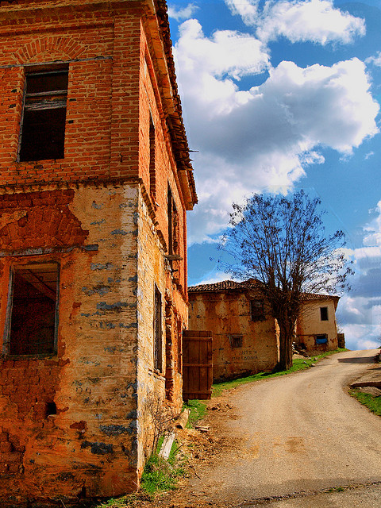
Activities for Visitors
These activities include:

http://www.spiritofdiscovery.gr
http://www.prespana.gr
http://www.spp.gr
http://www.ctp.gr

- Cookery workshops
- Fishing
- Hiking trails
- Boat trips
- Bird watching
- Treasure hunt (for children)
- Horse riding
- Bike riding
- In winter: ski

Important events
Panigiri

The 'Panigiri' is a traditional open-air festival that usually takes place in the main square of a village in order to celebrate the name day of the patron saint of the village. It involves a live band playing the traditional music of the region, dancing, and food.
Date | Village
11th and 12th of May | Agios Germanos
1st of June | Karyes
12th of June* | Andartiko
24th of June | Laimos
26th of July | Kallithea
26th of July | Vrondero
5th and 6th of August | Platy
14th and 15th of August | Psarades
26th of October | Lefkona
* please check with CTP info@ctp.gr if it is taking place

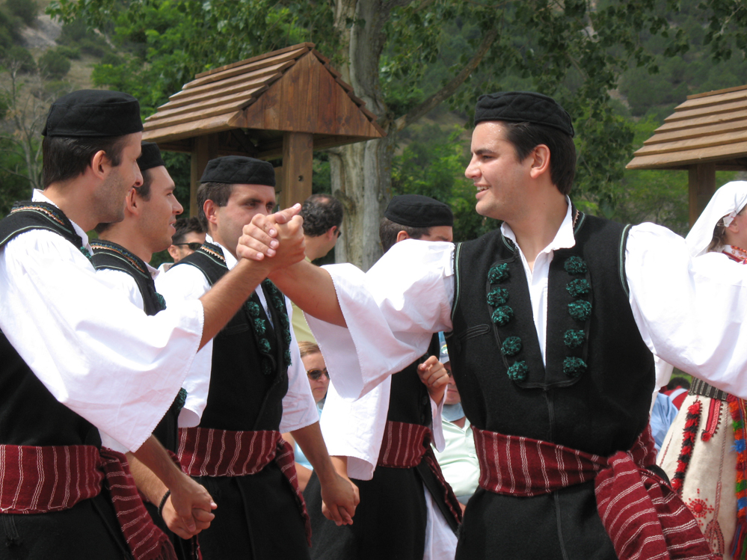

Prespes Festival
Location: In front of the Basilica of Agios Achillios, on the island of Agios Achillios
Date: last weekend in August
Description: The Prespia Festival, one of the most important cultural events in the Balkans, is held every year. Events take place on the island of Agios Achilios in the small Prespa lake as well as various villages in the Florina prefecture. It attracts a great number of visitors from Greece and many of the neighbouring countries.

International Youth Exchange
Location: Laimos
Date: check with CTP info@ctp.gr
Description: The Cultural Triangle of Prespes www.ctp.gr is organising since 2003 every year in summer an International Youth Exchange (Meeting)

What can you in Prespa

WITH JUST ONE DAY
- Visit the lakeside village of Psarades with its traditional buildings, history of fishing and indigenous dwarf cattle.
- Take a boat trip out on the Great Prespa Lake to visit the hermitages along the coast from Psarades.
- Visit the stunning ruins of the 10th c. basilica on the island of Agios Achillios on the Little Prespa Lake.
- Explore the beautiful traditional stone architecture of the village of Agios Germanos; visit its 11th c. church with original frescos and stop at the information centre at the square to get all the info you need.
WITH A WEEKEND OR THREE DAYS
- Take a short walk amongst Prespa’s stunning scenery; perhaps out to the Roti headland across the bay from Psarades to look out across the Great Prespa Lake to Albania or up the small hill of Kale off the main road near Lefkona for great views of Little Prespa Lake.
- Enjoy a local specialty in one of the many lakeside tavernas of local carp slow baked in the oven with onions whilst watching the sun set behind the mountains.
- In summer take time to idle on the beach, perhaps enjoy some kayaking of beach volley and swim in the cooling waters of the Great Prespa Lake.
- In winter take to the snow covered slopes at Vigla for some skiing or snowboarding or simply watch the world go by in one of the cosy apres ski bars.
WITH A WEEK OR TEN DAYS
- Explore the island of Agios Achillios. Walk out to the beautifully 16th c. monastery of the Virgin of Porphyra, stroll along the tiny street of the islands village!
- Take a trip to the traditional shepherding village of Vrondero and stop for a glass of tsipouro in the village square. From the village you can walk down to the abandoned lakeside village of Angathoto, passing the old partisan hospital cave as you go to emerge into a valley opening onto the Little Prespa.
- Enjoy lunch at any one of a number traditional tavernas serving the local dishes. Not to be missed are beans cooked in the oven with the famous Prespa white beans and any of the delicious red pepper dishes cooked to grandmother’s recipes.
- Walk up to Zachariades’ cave from the village of Pili, and old headquarters for the partisans during civil war times.
- Take part in one of the activities organised by Spirit of Discovery an outdoor adventure company whose base is in the village of Agios Germanos. Anything goes from bicycling to snowwalking and orientation games for groups and kids. Slow down the pace and spend time watching some of Prespa’s unique natural life.
- There are bird watching towers all over Prespa and from these you can observe a number of very rare species including the White and Dalmatian pelicans for which Prespa is famous. The Society for the Protection of Prespa based in Laimos runs bird watching days and also will organise tours.
- Visit the distilleries of Agios Germanos and Platy, especially in November and December, the season for making tsipouro the local drink. Some still have music and dancing on cold winter nights around the blazing distillery fire, and plenty of tsipouro to keep you going!
- Follow all or part of the E6 walking trail as it rises above the villages of Agios Germanos and Laimos up into the mountains surrounding the two lakes. In spring the mountain meadows put on a sumptuous display of wild flowers including delicate orchids from which the local Salepi tonic drink is still made.
- Raise the heat on those summer nights by visiting one of the bars and cafes. The music is mixed but there will always be some traditional dancing and if you don’t see any plates being smashed well for sure you’ll be dancing on the tables with the best of them as the dawn approaches.
DAY TRIPS FROM PRESPA DURING A LONGER STAY
- The deserted village of Ano Kranionas sleeping quietly in hills and the villages of Korestia. This village shows a way of life as it might have been forever in the mountains of Northern Greece, where fields are still ploughed without tractors and the traditional welcoming hospitality of the Greeks may still be found.
- Nymphaio, with its unusual traditional slate and stone architecture and the famous bear sanctuary run by Arctouros where you can see rescued bears and learn all about them.
- For the more adventurous the nearby Albanian city of Korca with its huge daily market and many old style houses. The old village of Voskopoje with its Byzantine churches and the villages of Albanian Prespa situated on the lakeside within a national park. Hire a taxi at the border for the day to take you round all the sites.
- Pass through Florina with its riverside tavernas on the way to Bitola and Ohrid in FYR Macedonia. Bitola has an old quarter with a lively market on Fridays as well as many cafes, churches and old mosques. The city of Ohrid is world famous for its Byzantine heritage, situated on the shores of Lake Ohrid you can visit the castle or many churches or simply stroll in the shady lakeside streets before tasting the delicious local wines.
The charming city of Kastoria situated on a peninsula in the Kastoria Lake where many of Prespa’s pelican go to feed. Wander the old mansions or Museum of Folklore; tour around the peninsula stopping at the Byzantine monuments and churches; enjoy lunch and retsina from the barrel or simply stop at one of the many lakeside coffee houses and watch life pass by.

Responsible Behavior

Make your trip an opportunity to learn

The region of Prespes both a National constitutes Park and a cross-border park and is included in the list of Sites of Community Importance NATURA 2000. Be informed about the unique features of the region, the measures taken for its protection and the rules to be observed during your stay.

Assist in the preservation of wildlife and biodiversity
Be informed about the rare species of flora and fauna existing in the region; learn about their characteristics and habits, and the dangers they are facing from the pollution of the environment as well as people’s careless behaviour.

Explore the beauties of the region
Get out and about in the region and learn about the history, culture and daily life of the local people. Many times the best places are not found in the guidebooks but in people’s hearts. Visit remote villages, hidden gems and the more tranquil spots, or even our neighbouring countries, Albania and FYR Macedonia. The tourism stakeholders are knowledgeable about the area and can inform you, so don’t hesitate to ask.

Use public transport and other environmentally friendly ways to get around
For small local journeys, either cycle or walk. Don’t forget to be considerate so as not to disturb the fauna of the region; be attentive in the natural world, because even the smallest flower may be something rare.

Learn about the local culture and the culture of the region
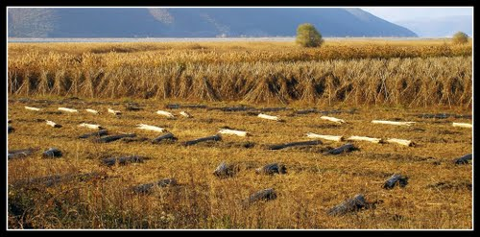
Be informed about the local customs, feast days, events and fiestas, the rural practices and the residents’ way of life. The tourism stakeholderscan provide you with any necessary information and they would like your stay to be both comfortable and memorable, so don’t hesitate to make enquiries.

Support the local economy
Buy local products such as: beans, salted fish, local tsipouro (a spirit distilled from grapes), fruit preserved in syrup, honey, jams and pasta (noodles and ‘trakhanas’) from the small shops which sell traditional products. These are produced in the traditional way with the loving artistry of men and women throughout the region.

Minimise environmental pollution
Put forward your own proposals for improving these practices to the residents of the region. In this way, you can also become actively involved with this effort.
Protect nature and the region you visit
Choose activities that do not impact on the flora, fauna and natural landscape and leave no marks or traces on the places you pass through. Collect your litter and transfer it to an appropriate place; otherwise, whatever you leave behind you will find again on your next visit, even if an entire year has gone by.

Prove that tourism and sustainable development can be compatible
Through the application of these rules, your active participation in the life of the Prespes region and the activities for its protection, you prove that tourism does not always mean a deterioration of the local characteristics and the degradation of the environment, but can be a means to better protect the region and integrate tourists into the local way of life

Information centers

Prespa National Forest Management Body
Website: http://www.fdedp.gr
Tel: 23850- 51870

How to get to Prespa

Bus:
Bus schedule from Florina to Prespa, last stop Agios Germanos
Tel:+30-23850-22430
Wednesday:
Departure: 7.30 and 13.00

Taxi:
TAXI AG.GERMANOS: +30-23850-51207, +30-6945-377954
TAXI LEFKONAS: +30-6977-795809
TAXI LAIMOS: +30-23850-51247, +30-6942-704496

Private Cars:
Rent a car in Thessaloniki or Kastoria tel. 30-24670-84000

Information on bus schedules:
KTEL Florina in Athens: +30-210-5130427
Bus station in Florina: +30-23850-22430
Thessaloniki: +30-2310-595418

Information
Cultural Triangle of Prespes
Laimos, 53077 Prespes, Greece
tel. 30-23850-51332, fax 30-23850-51332
info@ctp.gr, www.ctp.gr

The Cultural Triangle of Prespa
Cultural Triangle of Prespa (CTP) is an independent, non-profit local NGO situated on North-western Greece, on the borders with Albania and FYR of Macedonia. Active on a local, regional, cross-border and European level we implement activities in the Youth, Culture and Tourism Development sectors.
Established in 2000, CTP is focused in actions that strengthen the equal, qualitative development, contribute at the mobilisation of the people of Prespes – concentrating on youth and tourism stakeholders – and make the borders a comparative advantage.
More than 11 years now CTP is a reference point for the youth mainly from European countries, through the Youth Exchange, the welcoming of long-term European Volunteers, the sending of Greek Volunteers, as well as the organisation of actions for the non-formal education of children and youth.
Furthermore, CTP implements programmes concerning the research, preservation and utilisation of the cultural heritage, the mobilisation of citizens and institutions and the collaborations between them, as well as the development of an alternative model of tourism in a region rich in natural beauty and cultural heritage.
In June 2011 we inaugurated in Laimos a multiplex centre, which is housed in the premises of the old communal library and works as a lending library with free use of computers and wireless internet (WIFI), as well as an information point for visitors and tourists with rich audiovisual and printed material. The centre is also hosting workshops and actions of non-typical education, organises events, meetings and seminars in cooperation with the Municipality of Prespa.

Our goal is to make this place work as a meeting, education and awareness point for the locals, the foreign volunteers and the visitors and tourists. The library will be enhanced with books on general environmental and cultural topics, researches and publications on the area in order to attract students, scientists and other interested parties.

The main objective of the cluster of our actions is the improvement of the social consciousness of the people in our society and their active participation. The daily (Monday-Sunday) actions of non-formal education, the contact with volunteers from all over Europe and the cooperation on a regional level of bodies, youth and tourism stakeholders decreases the sense of isolation while increases the self-esteem and respect towards our community. The cooperation with the neighbouring countries shows that the borders can actually be simply "the door" to another area instead of a boundary line.
For more information about our organization, visit the following website:
http://www.ctp.gr

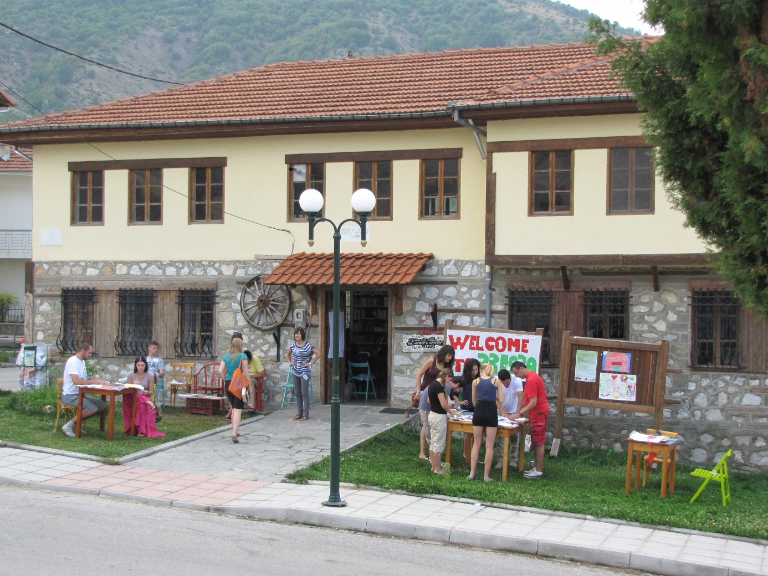
Some Important Links
- http://en.wikipedia.org/wiki/Lake_Prespa
- http://en.wikipedia.org/wiki/Prespa_(medieval_town)
- http://wikitravel.org/en/Prespa
- Prespa National Park: http://www.fdedp.gr/English/
- Society for the Protection of Prespa: http://www.spp.gr/spp/
- Municipality of Prespa: http://www.prespes.gr/

