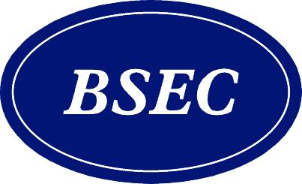
BSEC Business Council Forum
BSEC 25 Years of Cooperation: The Next 25 Years?
May 11, 2017 – Istanbul, Turkey

Forum’s Draft Concept Note

A quarter of century has passed in the blink of an eye, BSEC, for 25 years has been striving to bring life the projects to develop economic cooperation on the Black Sea Region. BSEC Business Council’s intention is to build stronger future for the Region with joint commitment and efforts of all Member States; as a result, today it’s time to investigate and establish cooperation’s next 25 years’ vision. To that end, BSEC Business Council Forum in İstanbul-Turkey will discuss what the Business Council needs to do in the future to strengthen economic and trade partnership in different sectors. In line with Turkish BSEC Presidency priorities, the BSEC Business Council Forum will elaborate on the next 25 years of the cooperation.

The Forum will be followed by a B2B session to facilitate follow-up and cooperation opportunities among BSEC members on different sectors. The Forum will also give opportunity to BSEC Business Council Board Members to present the key findings of the gathering directly to Economy Ministers from the Region.

Forum’s Draft Agenda

09:30-10:00 Registration & Coffee Break

10:00-11:15 First Session:
The Next 25 Years of Tourism, Energy and Transportation in the Black Sea Region

The first session of the Forum will focus on strategical topics of the region which are tourism, energy and transportation. The panel will enable Member States to exchange views and share knowledge of their own region in order to develop mutual understanding and friendly relations between the member states and to discover regions’ untapped market potential.

11:15-11:30 Coffee Break

11:30-12:45 Second Session:
The Next 25 Years of Business in the Black Sea Region (Trade, Banking, Finance, SMEs)

The second session of the Forum will create Black Sea Region’s business roadmap to maximize organization’s capability to flourish trade and economic activities in the region and to address key regional concerns. Agenda of the session will comprise of trade, banking and finance, and SMEs.

13:00-14:15 Lunch

14:30-15:30 Forum’s Closure Ceremony to be honored by the Economy Ministers

15:30-17:30 B2B Meetings

