CONSTANŢA

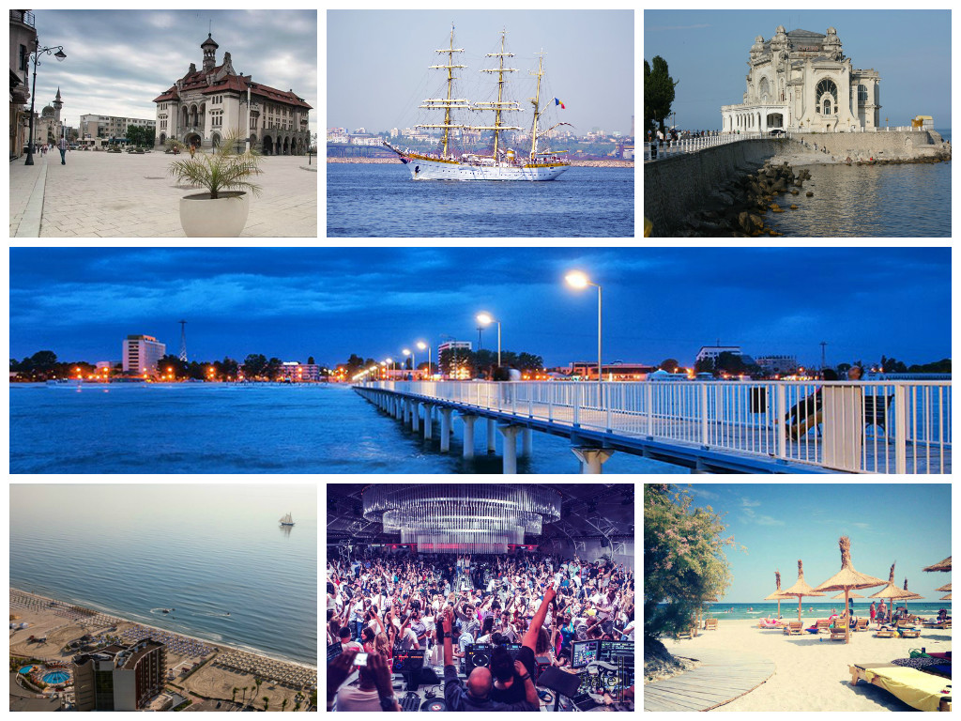

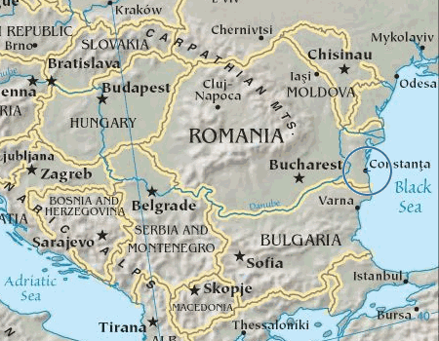
Constanta is the gateway to the Romanian Riviera, a beautiful stretch of coastline on the Black Sea. The area caters for all tastes, whether you want a relaxing time or an all-adventure action holiday.
Excellent summer weather, long sandy beaches and warm seawater make this an ideal destination for those wishing to relax, swim and simply get a tan. For those seeking adventure the area boasts unrivalled natural beauty, wildlife, and places of interest. Constanța (Romanian pronunciation: [konˈstant͡sa]), historically known as Tomis (Greek: Κωνστάντζα or Κωνστάντια, Konstantia, Bulgarian: Кюстенджа or Констанца, Turkish: Köstence), is the oldest still-populated city in Romania. It was founded around 600 BC. The city is located in the Dobrogea region of Romania, on the Black Sea coast. It is the capital of Constanța County and the largest city in the region.
Constanța is the administrative center of the county with the same name and the largest city in the EU Southeastern development region of Romania. The Constanța metropolitan area includes 14 localities within 30 km (19 mi) of the city, and, with 425,916 inhabitants, it is the second largest metropolitan area in Romania. The city is located on the Black Sea coast, having a beach length of 13 kilometres (8 miles). Mamaia, an administrative district of Constanța, is the largest and most modern resort on the Romanian coast. Mineral springs in the surrounding area and sea bathing attract many visitors in the summer.
The Port of Constanța has an area of 39.26 km2 (15.16 sq mi) and a length of about 30 km (19 mi). It is the largest port on the Black Sea, and one of the largest ports in Europe.
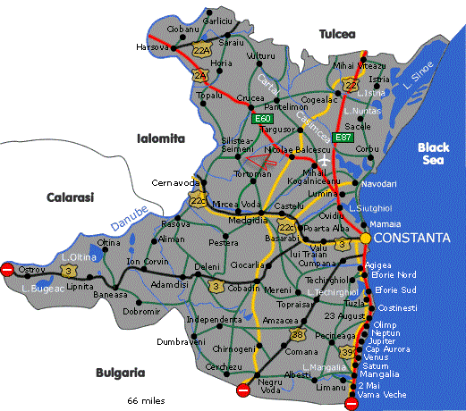
44°10.4′N 28°38.3′E
Constanta has around 283,872 inhabitants live within the city limits. The metropolitan area of Constanța has a permanent population of 387,593 inhabitants, i.e. 61% of the total population of the county, and a minimum average of 120,000 per day, tourists or seasonal workers, transient people during the high tourist season. The main minorities in the area are the Tatars and the Turkish.
From a religious point of view, most of the inhabitants are Orthodox, with a minority of Muslims.
One of the largest cities in Romania, Constanța is now an important cultural and economic center, worth exploring for its archaeological treasures and the atmosphere of the old town center. Its historical monuments, ancient ruins, grand Casino, museums and shops, and proximity to beach resorts make it the focal point of Black Sea coast tourism. Open-air restaurants, nightclubs and cabarets offer a wide variety of entertainment. Regional attractions include traditional villages, vineyards, ancient monuments and the Danube Delta, the best preserved delta in Europe.

CLIMATE
Constanța is one of the warmest cities in Romania. It has a moderate subtropical climate with considerable maritime and some continental influences. There are four distinct seasons during the year.
Summer (late May to mid-September) is warm, dry and sunny with a July and August average of 23 °C (73 °F). The beginning of summer brings plenty of precipitation, but by early July the weather becomes settled and dry. Most summer days see a gentle breeze refreshing the daytime temperatures. Nights are warm and somewhat muggy because of the heat stored by the sea.
Autumn starts in mid or late September with warm and sunny days. September can be warmer than June, owing to the heat accumulated by the Black Sea. The first frost occurs on average in mid-November.
Winter is much balmier compared to other cities in southern Romania. Snow is not abundant but the weather can be very windy and unpleasant. Winter arrives much later than in the interior and December weather is often mild with high temperatures reaching 8 °C (46 °F) - 12 °C (54 °F). Average January temperature is 1 °C (34 °F). Winter storms when the sea becomes particularly treacherous are a common occurrence between December and March.

HISTORICAL LANDMARKS
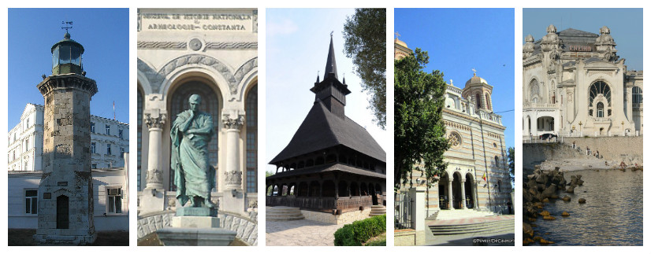
Constanta is more than just the entry point to the Black Sea coast. It is a place with a long and interesting past, attested by its many Roman vestiges, historic buildings, facades and mosques that color the Old City Centre. Constanta sits within the Dobrodgea region, a region long associated with the Romans and ancient Greeks. Many monuments and historic buildings remain and can be seen within the Old City Centre of Constanta and the surrounding county. Visitors are always keen to visit the beautiful monuments of Tropaeum Traiani at Adamclisi or the amazing Greek ruins at Histria.
Situated at the crossroads of several commercial routes, Constanța lies on the western coast of the Black Sea, 185 miles (298 km) from the Bosphorus Strait. An ancient metropolis and Romania's largest sea port, Constanța traces its history some 2,500 years. Originally called Tomis, legend has it that Jason landed here with the Argonauts after finding the Golden Fleece.
MUST SEE - Archeology and National History Museum, Ovidiu’s Square, Archeological Park, Roman Mosaic Edifice, Folk Art Museum, St. Peter and Paul Orthodox Cathedral, The Great Mosque, the Casino, the Genoese Lighthouse.

ROMANIAN RIVIERA

The main towns and summer resorts on the Romanian Riviera are:
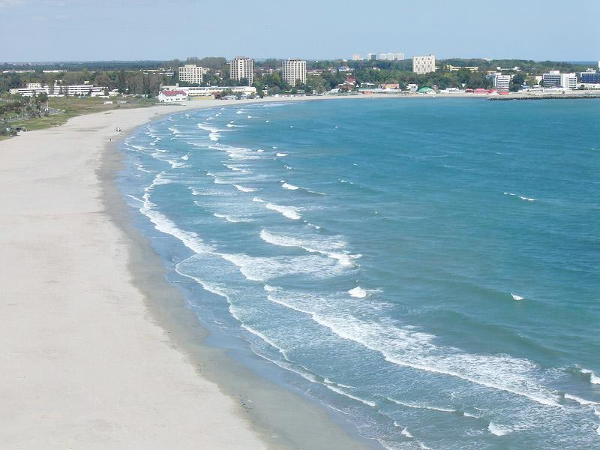
- Constanta
- Mamaia
- Navodari
- Eforie
- Techirghiol
- Costinesti
- Neptun - Olimp
- Jupiter - Cap Aurora
- Venus
- Saturn
- Mangalia
- Vama Veche – 2 Mai

FUN, SEA AND BEACHES
The Romanian Riviera is famous for long, beautiful beaches, very fine sand and long warm summers. From May until September good weather is almost guaranteed! And, if you get bored simply laying on the beach getting a tan, there are always lots of fun things to do to keep yourself amused - sports grounds, open-air pools, discotheques, clubs, amusement parks, open-air theatre, water sports – yachting, snorkeling, diving and fishing.
MUST DO - Mamaia - Aqua Magic, Sky Gondola, Cruise to Ovidiu Island, Constanta - Aquarium, Dolphinarium, double-decker City Tour, Murfatlar wine tasting, Eforie Nord - Zamfira’s Wedding traditional show, Mangalia horse riding, Tuzla Sky Dive, sea cruises.

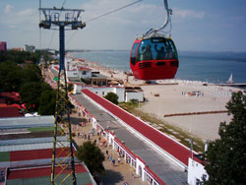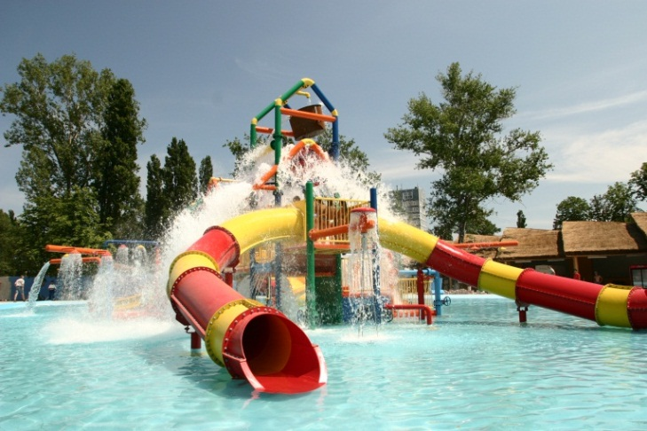

WILD DANUBE DELTA
Listed by UNESCO as a World Heritage Site, the Danube Delta is famous for being one of the greatest un-spoilt wetlands in the world. After flowing for 2,860 km across Europe the River Danube has created this unique environment. It is probably the most beautiful delta on Earth and a shining example of biodiversity. Home to over 300 species of birds, 60 varieties of fish and 1,200 species of plants and trees, the delta is a great place to view wildlife, explore or simply to relax.
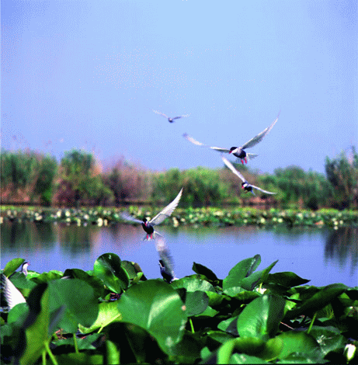
The Danube Delta is a natural reserve known worldwide for its beautiful landscape. In Romania it is an important tourist attraction. It has has numerous areas that were declared natural reservations and included in the United Nations’ list of natural monuments. The Danube Delta Biosphere Reserve is a labyrinth of water and land, made up of countless lakes, channels and islands.
The area is particularly well known for the abundance of fish and birdlife: about 90 fish species (such as sturgeons, sheatfish, carps, herrings, pikes) are fond here and 312 important bird species are present in the Delta.
Swamps are home to large numbers of herons, egrets, ducks, geese and other birds of the prairie as finches, woodpeckers, Grey Shrike, owls and various songbirds. It is also one of the last refuges for the European mink, the wildcat, the freshwater otter and the globally threatened monk seal.
The area has been also studied by the famous French scientist Jacques Cousteau
The Danube Delta represents the area with the lowest elevation of the country. It is a plain formed by alluviation. Dry land represents only 13% as most of the delta is covered with marshes and lakes.
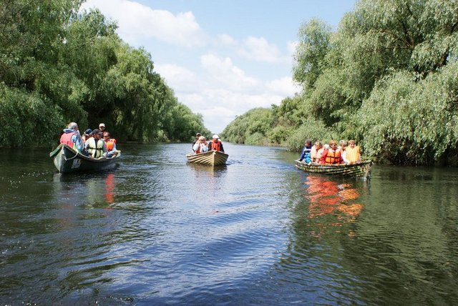
Danube covers in Romania a distance of approximately 1,000 km, being favorable to navigation everywhere on its stream, and has as its tributary streams through Tisza River, all Romanian rivers.The rivers which are discharged here go through the three channels of the Danube into the Black Sea, forming the country’s river network and facilitates access to the Planetary Ocean.
It is the largest delta in Europe as well as the longest wetland in the the world with an extensive water maze. The best season to visit the Danube Delta is in May, when a number of migratory birds return here, the weather is very pleasant and flowers are abundant, but you can visit also during the summer, when it is very hot, and winter, especially for birds’ study lovers.
Danube splits in two parts in the West of Tulcea, and the Southern channel splits once again at East forming thus the three main channels of the Danube: Chilia which forms the border with Ukraine in the North, Sulina – the central channel- which goes East to town with the same name and Sfantu Gheorghe channel in the most Southern part, the last two channels having a rich tourism potential.
Despite the fact that Sulina arm is largely artificial, increased in the 1870s in order to facilitate access to countries from Central Europe to the Black Sea, it gets heavy traffic, many visitors arriving here accommodate in Crisan, Maliuc villages, or in Sulina town.
Letea Forest, located between Chilia and Sulina channels, it is recognized as a natural reserve. In the depressions between the dunes grows woody vegetation consisting of many species of trees. The uniqueness of the forest it is also given by the numerous number of climbing plants. Here have found shelter thousands of species of vertebrates and invertebrates, many of them are unique species at national, European and world level.
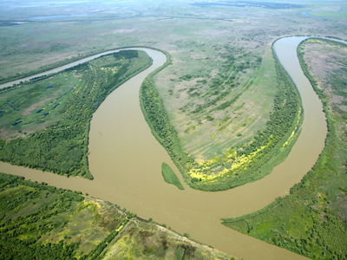
St. Gheorghe- – the most tortuous arm of the delta, it is also the quietest of the three arms, with some straight portions channeled. The fishing village, with the same name, is a beautiful and remote place despite the fact that many visitors, especially from Bucharest, buy holiday houses in this area.
The main attraction in Sulina is the old lighthouse from city center, which dates from 1802 and measures about 50 meters. The lighthouse, is opened to the public from Monday to Friday between 14:00-18:00 (entrance fee).
St. Gheorghe is an attractive place with a fine beach which offers great conditions for studying of the various species of birds, becoming the most sought place for accommodation in Delta, once known for the production of caviar.

MUST DO - fishing, bird watching, exploring fauna and flora, boat safaris through channels, waterways and lakes, sunset cruise on the mighty Danube, motor or row boat excursions
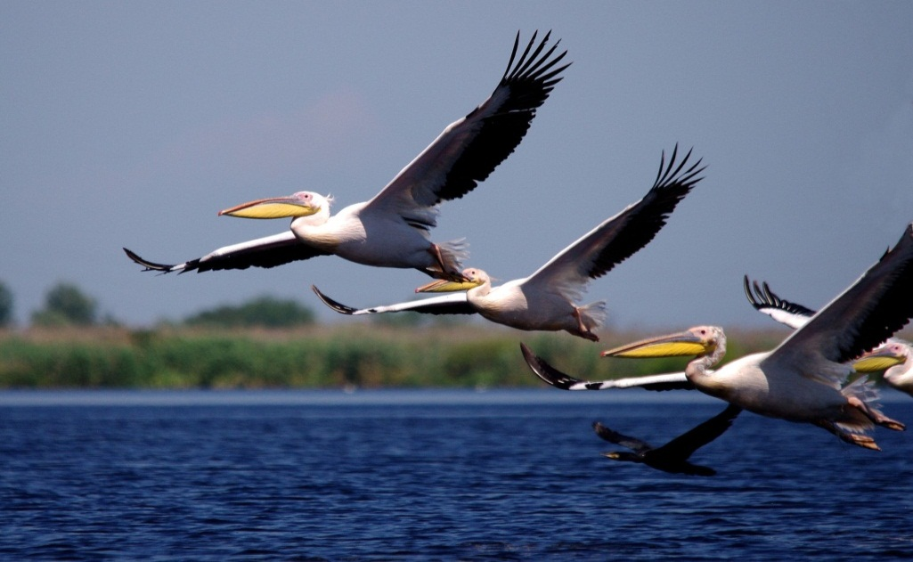
EVENTS From air shows to music, film and dance festivals, Romanian Riviera offers plenty of events all summer long: Navy day, Constanta Days, Tomis Ancient Festival, Mamaia Pop Music Contest, Mangalia Music Festival, International Ballet and Opera Festival, Concerts, famous DJ’s performances at Liberty Parade – the biggest street music and dance festival in Romania, Stufstock Festival - sleepless nights on the beach; rock music, film, theatre and photography. Aeromania - an air show involving high-performance airplanes racing around a tight circuit at near ground level, an ultimate battle for air supremacy fought by highly trained military and civilian pilots
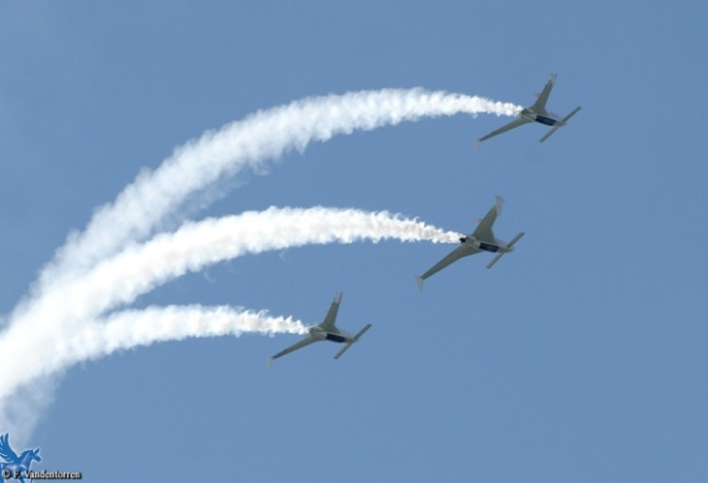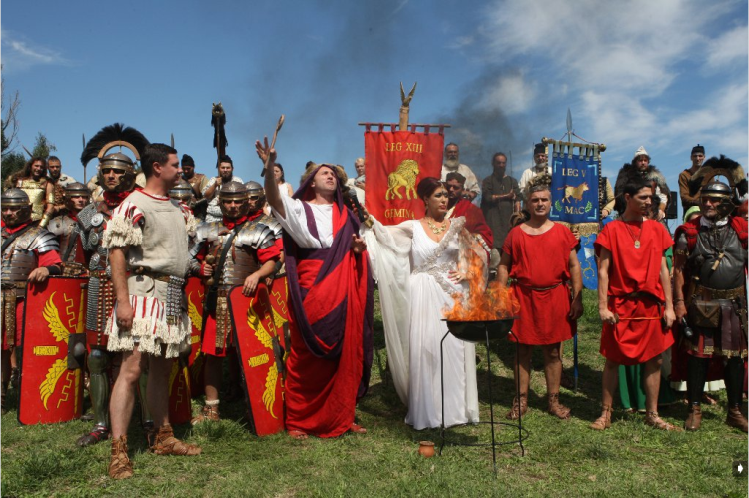
THE BLACK SEA SPAS Romania has a very big potential to become a very important destination in Europe for Spa Vacations. Romania has an important natural potential for Spa and balneal treatments. Since Roman times, people have been coming to the Black Sea to get treated for specific ailments or to simply relax being pampered in one of the local spas. Thanks to the thermal springs, therapeutic climate and beautiful beach locations Romania’s spas are the perfect place to take a wellness break. The therapeutic factors of the mud from the lakes on Black Sea Coast are well known. Eforie Nord and Mangalia Spas specialize in mud baths (the mud is taken from the area's salty lake waters) as well as in world famous "Gerovital" and "Aslavital" original treatments. The natural factors are complemented — under attentive medical care — by physiotherapy, acupuncture, electrotherapy and medicines produced from plants. All this are completed by a specialized personnel to contribute to the restoration, prevention, and maintenance of health, a diversified infrastructure adapted to the health industry (hotels and pensions, treatment facilities equipped with the most modern medical equipment), traditional methods and natural products, and potential guests can have a complete image of the Romanian health spa potential.
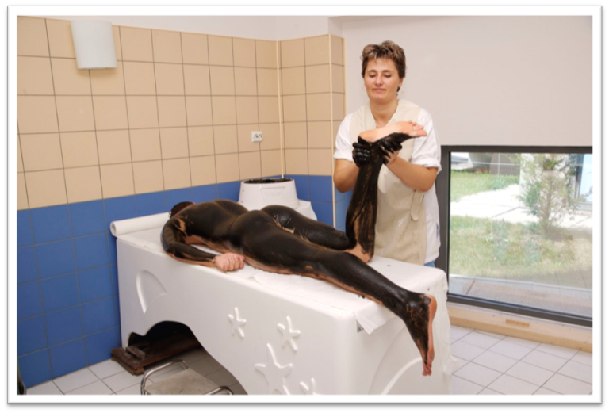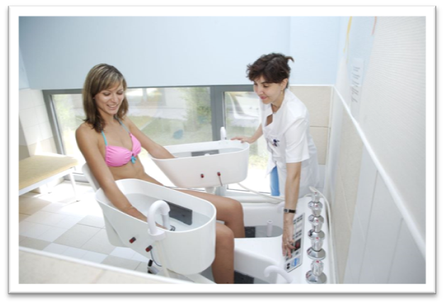
Eforie Nord and Eforie Sud - Ana Aslan Spa - Therapies are based on various kinds of procedures using sapropelic mud and salty water from the Techirghiol Lake.
Eforie Nord is located on the Romanian Black Sea coast, nearby Lake Techirghiol, whose waters have long been held as cure for arthritic, rheumatic, internal and nervous system disorders.
Eforie Nord was established in 1894, when a clinic first opened here.
Later, under the patronage of King Carol I (1839 – 1914), a health resort sprang up. Besides the sea air and sun, another curative factor is the rich, black, sapropelic mud – known locally as namol – from Techirghiol Lake.
Today, Eforie Nord treatments include mud baths as well as world-famous Gerovital and Aslavital original rejuvenation treatments.
Types of procedures:
Warm baths with concentrated salt water coming from the Lake Techirghiol or higher; warm baths with mud; warm mud wraps; aerosols; electrotherapy; hydrotherapy; physiotherapy; Pell Amar treatments, Gerovital and Boicil Forte.
Treatments:
- Arthritis and rheumatoid disorders
- Breathing and cardiovascular afflictions
- Endocrine system problems (hyperthyroidism and hypothyroidism)
- Gynecological afflictions
- Nervous system disorders
- Peripheral nerve diseases
- Skin problems

Neptun and Mangalia Spas specialize in mud baths, electrotherapy, kinetic therapy, hydrotherapy, warm mud wrapping, massages, and warm seawater pools.
Built on the site where the city of Callatis stood 2,400 years ago and where ancient stone tombs, statues of gods and other artifacts have been found, Mangalia provides treatments for afflictions related to the kidneys, digestive and nervous systems, skin and liver. Its name comes from the Byzantine word Pangalia, meaning "the most beautiful," and it developed as a spa resort in the 1940s.
The southernmost Romanian town on the Black Sea Coast, situated at the same latitude as the French city Nisa, benefits by many natural resources: sapropelic mud from Techirghiol Lake, sea water, sulphurous waters, and a marine bio-climate, rich in saline aerosols and solar radiation, which stimulate the human organism.
While in Mangalia, you can visit the Callatis Archeological Museum, the ruins of the Callatis Fortress (7th century BC), the Syrian Basilica and the 16th century Esmahan Sultan Mosque, the oldest mosque in Romania.
Treatments:
- Arthritis and rheumatoid disorders
- Endocrine system problems (hyperthyroidism and hypothyroidism)
- Gynecological afflictions
- Kidney and urinary diseases
- Peripheral nerve diseases
- Post-injury and post-operative rehabilitation
- Respiratory afflictions
- Skin problems

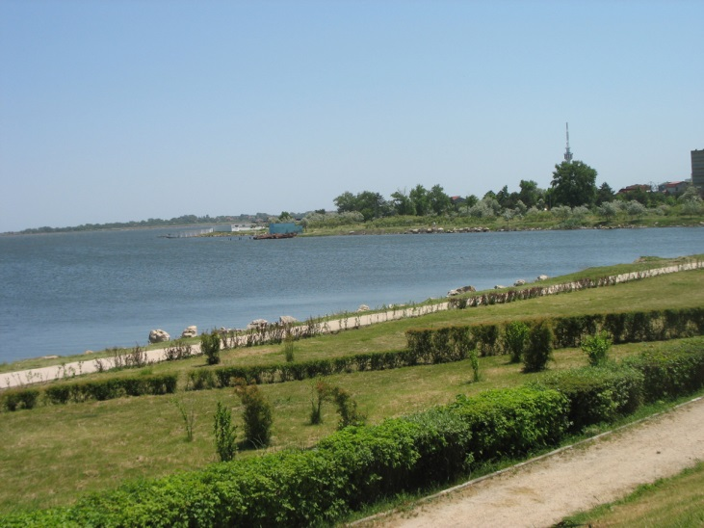
Techirghiol Sanatorium - the balneal and recovery sanatorium benefits from the existence of one of the most modern balneal-physical-kinetic treatment bases from our country.
Techirghiol benefits from the existence of special natural conditions, resulted from the presence of sanogen natural factors: the climate, the sapropelic mud, the chlorized-sodium-iodized water of the lake.
Considering the importance of balneal treatments considered miraculous and unique in Europe, whose key factor is the mud of Lake Techirghiol,a result of fauna and flora of the lake with the same name and strong hypertonic salt water of the lake, with a concentration of about 80g per liter of mineral salts and which represents a real therapeutic water, as well as the medical specialized staff providing balneofizic treatment of patients hospitalized in the three sections of the sanatorium, we are pleased to offer a stay of recovery in the Techirghiol Balneal complex as detailed below, rooms in the B Pavilion newly renovated (with private bathroom, air conditioning, refrigerator, LCD TV, cable, wireless internet, new furniture, maximum comfort).
The lake water is rich in chlorine, sulfur, bromine, sodium, magnesium as well as hypertonic and is used in applications as general cold baths (lake immersion) or warm baths (in bath tubs or pools)
- Cold saline Bath or the immersion in the lake water is done progressively as duration (5-10 minutes in the first days up to 20-30 at the end of the cure) as well as number (one bath in the first 3-4 days up to 3-4 immersions at the end of the cure)
- Hot saline bath can be prescribed and done daily as unique major hydro-therapy procedure or at two days alternating with mud application or with a general warm bath with plant extracts. The temperature at which the saline bath is prescribed is in the thermoneutral domain respectively around 37.5-38 degrees Celsius. For hidrokinetotherapy the water is heated at 35 degrees in the cool/ warm domain.
3.The mud is used for cold anointment , warm mud baths and hot packing.
- The mud anointment is a therapeutic complex composed by the successive contrast between hot and cold and general heliotherapy applied progressively. The mud anointment is practiced in the summer season, on the special arranged beach. The number of mud aplications per day remains constant throughout the duration of the cure, only one per day.
- General warm mud bath is done using 10 kg of mud diluted by 120-150 l of sodium chloride water from the lake. The applying temperature is 37-39 degrees Celsius; termalneutrality for mud is at 38 degrees Celsius. It lasts 20-25 minutes and the temperature is kept constant by adding hot water during the middle of the bath. After, the pacient takes a warm shower for mud removal and a short cold shower, to prevent systemic blood vessel expansion. The general mud bath is done once in two days, alternated by a salt bath (in the hydrotherapy pool ) or with plant extracts.
- General warm wrapping is done using 10-15 kg of mud heated at 42-45 degrees C. The mud is spread on the surface of the body from the cervical region to the legs. The pacient is wrapped in a sheet and a blanket and is applied a cold compress to prevent increased blood vessel expansion in the brain while the procedure lasts for 30 minutes. After the time expiration mud is removed with warm water at the shower. The procedure ends with a short cod application to prevent vasoplegia produced by the heat. Packaging is made once every two days, alternating with warm general bath with water from the lake or plant extract bath.
MUST DO - Gerovital rejuvenation treatment, mud wrappings.

MAMAIA
Mamaia is the largest and best known resort on Romanian Riviera. Located in the northern part of the seaside, Mamaia has a privileged position. The resort is attached to Constanta city and separates Lake Siutghiol of the Black Sea. The preferred destination of tourists during summer, Mamaia has been the subject of an ample process of modernization, gaining a beautiful western air. The palm trees, spectacular fountains, fashionable events and sensational shows, restaurants and luxurious clubs, quite terraces, promenade areas, Water Park, telegondola and entertainment centers, all these facilities make Mamaia a resort of fine taste, entertainment and relaxation.
Mamaia resort was gifted with one of the largest beaches in the whole Europe. This streteches on a distance of almost 10 km, between Constanta and Navodari city, and its width reaches almost 200m. The beach is covered with fine sand, without excessive stones and shells, and the entry in the sea is done smoothly, the depth of the sea growing gradually on a rather long distance. For safety reasons, the protection and comfort of the tourists, there are lifeguard centers arranged on the beach, first aid tents, public toilets and sites of selective collection of waste. A large part of the beach is arranged with chaise longs and umbrellas which you can enjoy by paying a fee, but there are areas where you can enjoy them for free. The beach is crowded with beach bars and terraces, the perfect places where you can hide from the heat next to a cocktail or an ice coffee.
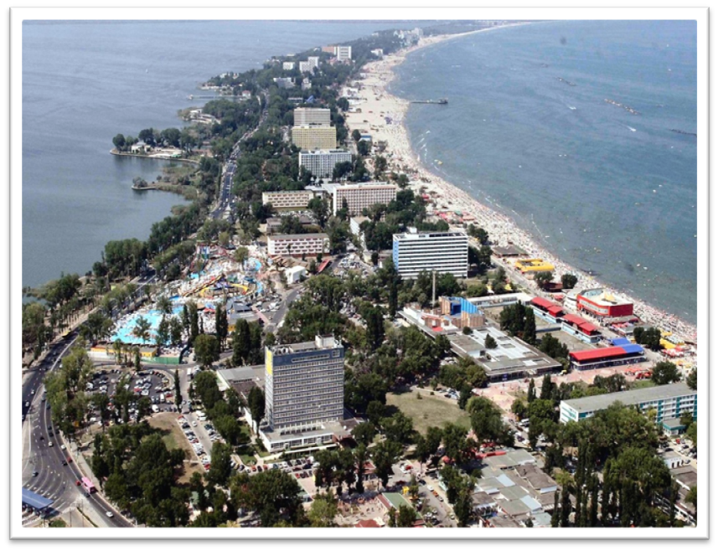Mamaia is the largest resort of the Romanian seaside, and this mirrors in its accommodation capacity. There are over 70 hotels and villas which have till 5 stars offering approximately 30 thousand places to stay. The popularity the resort enjoys created and adequate environment for building new accommodation places, thus in the last few years beside the traditional hotels new buildings have appeared, which offer very good conditions for accommodation: Mailbu Hotel, Florida Hotel, Palm Beach Hotel, Laguna Hotel, Club California Hotel, Del Mar Hotel, Richmond Hotel and so on. In order to keep up pace with modernization of the resort, the old hotels themselves were renovated, many of them acquiring an elegant air and full of refinement: Vega Hotel, Rex Hotel, Iaki Hotel, Flora Hotel, Savoy Hotel, Golden Tulip Hotel, Palas Hotel, Mercur-Minerva complex and so on. Since the tastes and requirements of the tourists grow from one season to the other, more and more hotels designed spaces for treatment and relaxation with swimming pools, saunas, fitness centers, sport fields, beauty and massage saloons where the tourists can relax and can enjoy modern treatments: Iaki Hotel, Vega Hotel, Palm Beach Hotel, Rex Hotel, Mamaia Hotel, Savoy Hotel and others. As long as you find yourself in Mamaia resort you don’t need to worry about what and where you eat. There are plenty of restaurants and terraces, many of them being placed on the one side and the other of the cliff. From fast-foods and ice cream shops until “pretentious” restaurants. Mamaia has them all. You can eat from various cuisines: Lebanese, Italian, Chinese, Turkish, Greek or even French, and, most important you can eat being saturated no matter the budget you have. If your seaside holiday doesn’t limit itself only to the chaiselong, Mamaia resort is the perfect destination. The resort offers the tourists a multitude of possibilities regarding fun and leisure time, no matter the money in your pocket. The recreational centers are an inexhaustible source of entertainment for those who love water sports, in Mamaia resort exist many such centers both on the sea shore and the lake shore. The tourists can enjoy the pedal boat, parachute lifting, windsurfing and yachting, banana towing, ski jet promenades, nautical ski, diving and sailing boat rides.

The Ovidiu Island is one of the right places for relaxation. Wrapped by legends of the past, the island is today a wonderful touristic complex which contains a restaurant, accommodation places and a wonderful garden. You can reach the island by boat which leaves the Casino area at set intervals. Aqua Magic is another attraction of the resort which offers fun at its best.
Inaugurated in 2003, Aqua Magic is the first park in the country which offers the tourists modern water installations. The telegondola in the resort is a means of transport which allows you to admire the surroundings for 7 minutes from 50 m altitude, on a 2 km distance. The Holiday Village is the place where you can find souvenirs stalls, shopping galleries and Romanian cuisine restaurants, which are designed as small houses from different Romanian regions. The “Luna” entertainment park is the destination for fun and amusement which you can avoid once you are spending your holiday in Mamaia. Full of games and colored lights, the park offers installations which are adjusted to all ages. There are plenty of sport fields in Mamaia resort, many of them being functional during winter time. You can challenge your friends to a football or tennis game on the fields of Iaki , Oxford, Mamaia or Palm Beach hotels and also in the IDU complex or Sen. There are volley ball fields arranged on the beach which you can enjoy for free. A walk on the cliff is a relaxation method available to everyone. Closed to cars traffic, the cliff of the resort is bordered by terraces and beautiful hotels, green areas, shopping galleries, souvenir shops and the fine sand beach. The most famous walking areas are those from Perla and Casino areas. There are gardens with benches for rest and artesian wells in Perla area. Here you can find also the Summer Theater, a place where entertainment shows and concerts occur all along the summer time. In the area of Casino a spectacular artesian well can be found, beautifully lit at night. The tourists can walk through the water jets or they can rest on the benches which border the small square. The Casino area is the place where open air shows and thematic parades take place. The night clubs in Mamaia resort are famous for their effervescence and elegance. You can have fun till dawn at unique parties, organized in their own style by the clubs in the resort. Trips to various attractions from Dobrogea are organized by the travel agencies or hotels and they offer you the chance to find out details about the culture and customs of the place.

TOP HOTELS
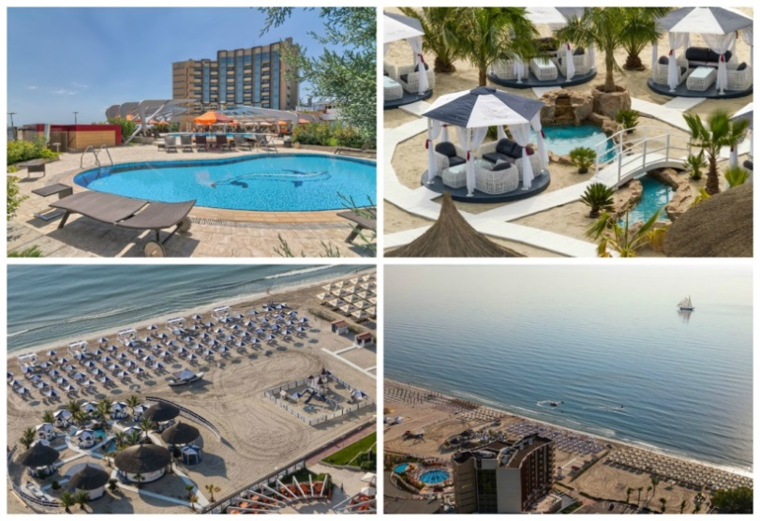
VEGA HOTEL *****
Vega Mamaia Hotel 5 stars is located on the cliff in the north of the resort, its direct exit is to the beach.Opened in 2008 summer, Vega is one of the most luxurious hotels of the resort.Designed respecting feng-shui principles, Vega Mamaia Hotel provides to the tourists 125 double rooms, family rooms and apartments, located on 8 floors. You can admire the sea from the terrace on the last floor, you can serve various dishes in the restaurant, you can relax on the private beach, at the warm swimming –pool or inside the SPA center, or children can play on the playground. Vega Mamaia Hotel is opened all year round.

GRAND HOTEL REX *****
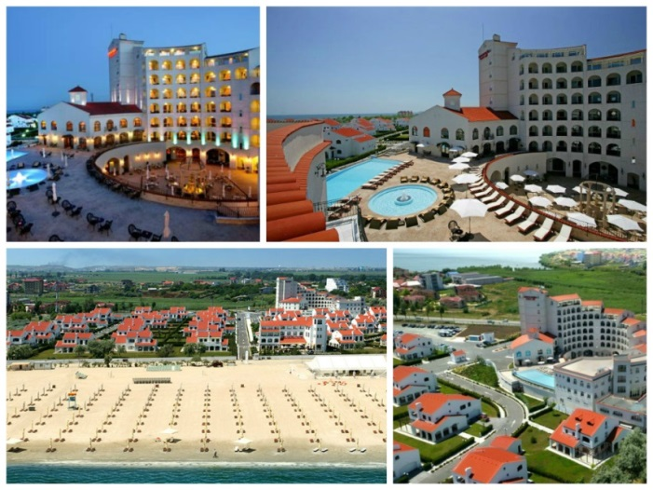
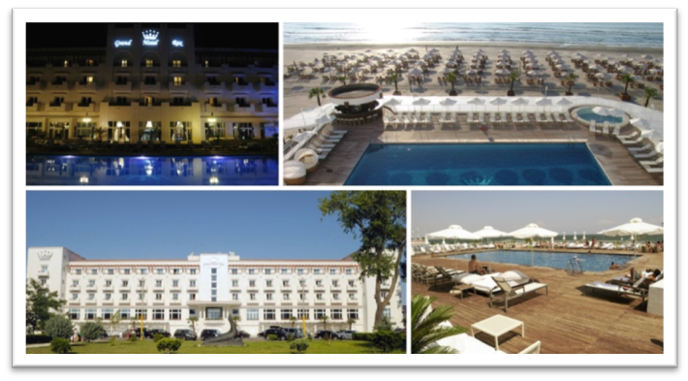
Rex Mamaia Hotel 5 stars is located in the northern part of the resort, between the cliff and the beach. One of the oldest hotels in the resort, Rex Mamaia offers superior services and facilities which are specific to the 5 stars classification. The guests of the hotel can enjoy accommodation in the 102 double rooms and apartments of the hotel with large surfaces and elegant design. Rex Mamaia Hotel features a Conference Center with 4 fully equipped halls. The restaurant with a terrace, outdoor swimming pool, SPA Center, private beach and secured parking lot are the facilities you can enjoy during your stay at Rex Mamaia Hotel.

ARENA REGIA HOTEL*****
Arena Regia Hotel (5 stars) takes advantage of its excellent position in the north of Mamaia resort and offers a unique experience on Romanian seaside, through the inspired combination of design, special attention to details and flawless quality services. Arena Regia Hotel ( 5 stars) has 53 matrimonial double rooms, 10 twin double rooms and 8 apartments. All the rooms and apartments are equipped with custom furniture, massive wood floor, luxury sheets, bathrooms plated with natural stone, LCD tv, balconies and terraces, air conditioning, safe, minibar and internet. Arena Regia Hotel also has a fitness center, with a wide variety of high performance equipment and trainers who are there at your disposal, conference halls with elegant spaces which are fully equipped and a SPA center, a peaceful oasis where you can spoil yourself with professional beauty and health treatments. The hotel also features 2 elegant restaurants where you can enjoy both French and Italian cuisine.
PHOENCIA LUXURY HOTEL*****
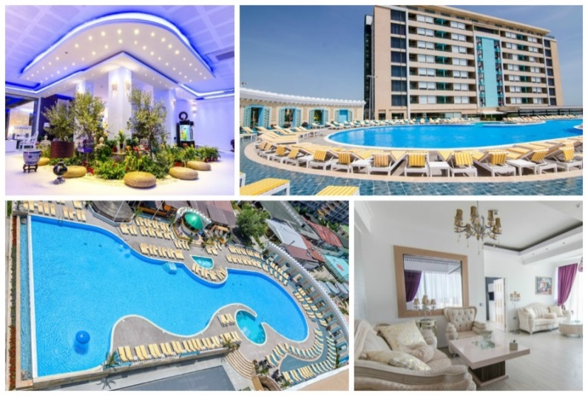
Phoenicia Luxury Hotel is located in a quit area of Norther Mamaia resort, right on the seashore. Built and opened in 2013, the hotel provides its guests 160 accommodation spaces both leisure and entertainment interests and not the last for families with children of all ages. All the rooms provide side sea view and a generous accommodation space, lookin to 45 square meters for the double rooms and 71 square meters for suites. All the accommodation spaces are modernly arranged and designed, equipped with LCD TV, cable TV, individual air conditioning system, WiFi connection, card access, minibar, coffee maker, beach towels, bathroom with shower/bathtub and hair dryer. In the hotel you will find 4 specific restaurants: Byblos, Babel, Kasttane and Italian, where you can enjoy various culinary experiences. The complex provides 6 heated water swimming pools designed both for adults and children. The hotel's beach provides soft sand and it is arranged with sunbeds, umbrellas and baldaquins. Phoenicia Luxury Hotel owns a sports center with soccer, volleyball and tennis courts. Outdoor, near the swimming pool a fitness area is available for exercise enthusiasts. Besides all the facilities mentioned above, Phoenicia Luxury Hotel also provides free parking lor and baby cots.

CUISINE
The central characteristic of the Romanian cuisine is its great variety. It is a cuisine influenced by repeated waves of different cultures. The main ingredients used by Romanian chefs are meats such as pork, beef and lamb, fish, vegetables, dairy products and fruit.The cuisine of Dobrogea, mainly based on fish, as the region is close to the Black Sea, the Delta and the Danube River, is a mix of Romanian, Greek, Turkish, Tartar and Bulgarian flavors and recipes.

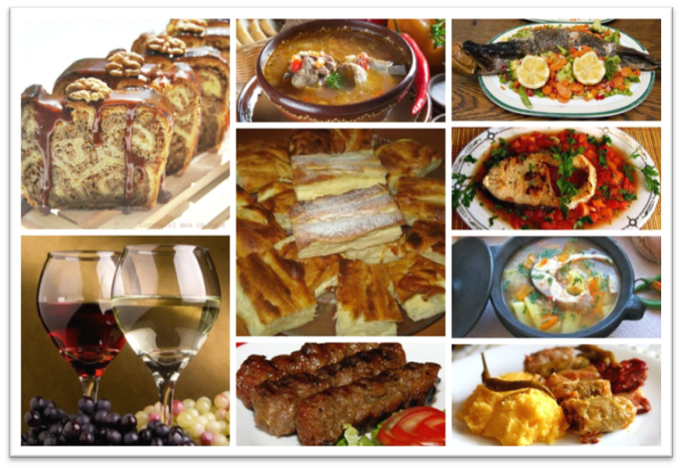
LOCAL PRODUCTS
Wine
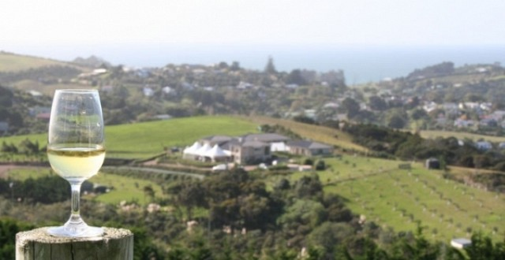
You haven’t met Dobrogea if don’t know its famous wines. So in your way to the seaside, stop to find out the story of Dobrogea’s wines, a story older than 2,000 years since Dacs inhabited this land. Usefully, this region is also called the wine birth place. More than 300 days of sunshine a year, long and warm autumns and cool winds from the Black Sea make this region ideal for the production of sweet dessert wines such as late harvest Chardonnay and Pinot Gris. At the Murfatlar Vineyard, you can enjoy traditional dishes from the Dobrogea region and sample some of the finest wines, such as the award-winning Lacrima lui Ovidiu, 3 Hectare Limited Edition, Sec de Murfatlar and Rai de Murfatlar, while taking in the picturesque landscape from the wine cellar's terrace. Complete the tour with a visit to the Vine and Wine Museum, located near the wine cellar. On display, you will find ancient Greek and Roman amphorae and an impressive collection of wine presses, proof of Dobrogea's noble wine-making tradition.
ONE DAY TRIPS
Histria Fortress - The most ancient town in Romania
Histria was founded in the mid-seventh century BC by the settlers coming from Miletus, a city on the Aegean coast of Asia Minor. Close to the small gate near the city baths, outside the enclosure, the city museum is located, which was built by Vasile Parvan. In the museum hall are exhibited votive, funerary and decorative reliefs. There are also exhibited Greek objects made of glass, metal, bone or ivory and painted pottery. On the walls are embedded Romanan votive inscriptions attesting the name of the old villages around the city. You can get to Histria from Constanta by following the road that goes to Tulcea (DN 22) – after the intersection at Ovidiu – with Taliverde, there is a local road going through the villageNuntasi which goes to the citadelle’s ruins* (57 km).
Dervent Monastery
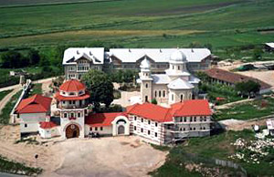
On the national road no. 3, at 130 km South-West of Constanta, around the village Galita, we discover between the hills of Dobrogea one of the most important religious places- Dervent Monastery. 2000 years ago, Saint Andrew preached christianity in the south of Dobrudja, together with his disciples. At some point, four of his disciples were stoned to death; four stone crosses stand today in the place of their martyrdom. Along centuries, the crosses proved to be endowed with curing power addressing both corporal and mental diseases. Inside the church there is a miracle-working icon of the Holy Virgin. It was donated to the Monastery in 1940. The miracle-working icon can be found left side of the narthex, on a tall iconostasis. The faithful one kneel underneath and ask the Holy Virgin for help. A Healing Spring is in the nut-tree orchard of the monastery. According to the legend, it is owed to St. Andrew who passed by the spot of the present-day monastery, and prayed for water, since he and his companions were thirsty. When he thrust his staff into the ground, water would spring up, and they say that those who drink or sprinkle it over their bodies in good faith are protected against evil and disease. The present day Monastery was built at the beginning of the 20th century.

Saint Andrew's Cave
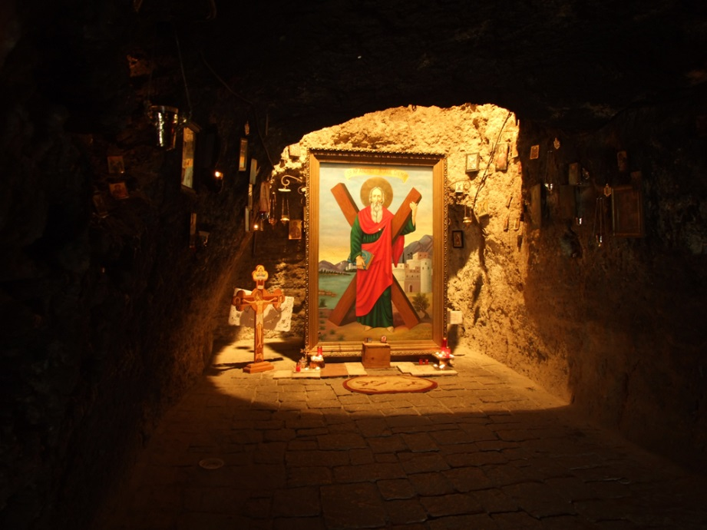
The Saint Apostle Andrew's Hermitage or Monastery stands for a Romanian Bethleem, since it is relating to the beginnings of Christianity on the present-day territory of Romania. Saint Apostle Andrew's Hermitage is situated on the tourist road Constanţa - Ostrov, close to the Ion Corvin forest. One can still see the stone that once served as an altar temple. The stone of the altar has the Holy Cross carved on all its sides. The wandering tribes who passed the territory along history could not turn the locals from their faith, culture and language. At about 50 m west from the Hermitage, one can see 9 wells known to have the best drinking water in the whole Dobrogea. They say that Saint Apostle Andrew preached for the first time over there and that he would teach people the religion of love and peace, cure the ill and baptize them in the name of God. During the 45 years of communism, the Hermitage became a mere cave, entirely emptied from all worship objects. The Hermitage resumed its religious functions in 1990. It became a Monastery by the Decision of the Holy Synod of the Romanian Orthodox Church, on 14 July 1994.
The churches made of chalk
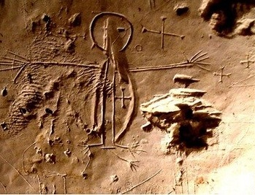
A miracle of the Christendom from Dobrogea, at just 15 km from the Black Sea, near Murfatlar town, there is a cave complex, carved into a chalk hill more than 1,000 years ago. If you arrive in this unique place, you will find a maze of rooms, inside of which were discovered several churches, a cemetery and even fireplaces. Though written in a mysterious language, with Greek, Cyrillic or Glagolitic letters, the inscriptions that still exist on the walls are still undeciphered.
Geologic Complex from Dobrogea Gorges
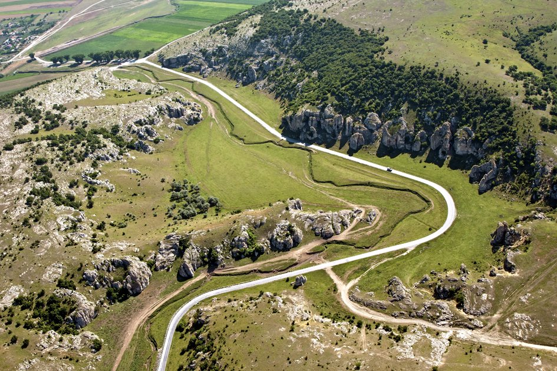
Dobrogea Gorges Geologic complex (“Cheia” Jurassic reefs limestone Complex) was placed under protection by Decision 425/1970 of the County Council of Constanta. The total area of the complex is 10,929 ha. From a paleontological perspective the limestone from Dobrogea Gorges host the richest fossil area with mesojurrasic fauna of the whole Casimcea synclinal. The site is important not only by its geo-morphological, paleontological, botanical features and landscape but also by its fauna. Species of reptiles, birds and bats are well represented here. On the site perimeter there are two important caves from a spelean and paleontological point of view.
La Adam Cave – important paleontological and archaeological discoveries rank this place among the most important in Europe. A numerous number of Quaternary mammal species were determined, important from a paleontologic perspective, 80 species of Jurassic fossils were studied and also an important piece was discovered here – a Homo sapiens fossilis molar. The cave houses many species of bats protected at European level, including Pipistrellus natusii, found only here. Gura Dobrogei Cave has over 480 m length, three entrances and two major galleries. The cave distinguishes by the accumulation of large quantities of compacted guano, forming mounds under the bat colonies which are sheltered during the summer on the cave ceiling. The bats have also given the name of the cage-The Bat Cave. Most species are protected and are considered species with an endangered status. Vegetation outside the protected area and the cave limit is characteristic for Dobrogea steppe.

Mangalia Stud Farm and Hippodrome
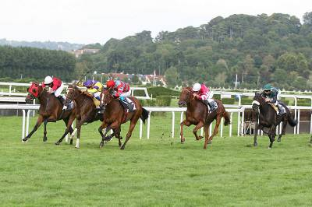
Mangalia Stud Farm is located at 3 km North of Mangalia Municipality and at only 500 m of the west shore of the Black Sea; the location was not chosen accidentally, the geoclimaterical conditions for breeding Arabian horses were taken into account; special climatic conditions have made possible the breeding of a Mangalia Arabian horse with special qualities. Mangalia Stud Farm is the biggest in South-Eastern Europe and it only has breed horses: Arabian pure blood, medium heavy horses and some ponies. The Stud farm is a place with tradition, which was founded in 1926. At that time, at Mangalia, Arabian horses were bred, brought from Jegalia, Cislau and Radauti Stud Farms. Between 1936 and 1941, the Stud Farm imported new breeds of pure blood stallions from Polland: El-Sbaa and Nedjari. The area of Mangalia Stud Farm exceeds 580 hectares, from which 400 hectares are cultivated with green crops which assure the necessary of food for more than 350 horses. Mangalia hippodrome, the only one in the country especially conceived for gallop races, lies on a surface of 19 hectares. During the summer, between the months of July-September, horse races take place where stud farms from all over the country and private breeders participate.Apart of its zootehnical profile, the Stud Farm represents also an excellent leisure and tourist attraction. The complex has a trot and gallop hippodrome, very well arranged, and inside of it riding is practiced, you can go on a walk along the Black Sea either on horse or by carriage. The pure blood Arabian Stallions are daily trained by 8 stud farm jockeys, which train each 5 horses. The 8 hour daily training consists of alternating rounds of trot, gallop, extended gallop and slight walks. The most beautiful spectacle is offered by the horses taken on the seashore, between Saturn and Venus resorts. A very well groomed horse may live, usually, around 30 years.
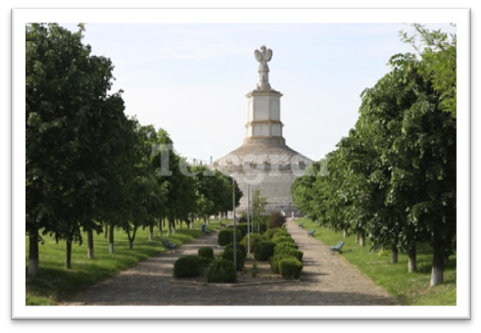
Tropaeum Traiani
The Triumphal Monument was 39m height, with a formular shape and a 38m diameter, being made up of a cylindrical nucleus with important sizes (12. 6 m height and 31 m diameter), built on natural masonry, at its base surrounded by a circular platform with seven stone stairs; the nucleus covered by stone slabs which continued with a row of 54 metopes (only 49 kept until today) having on their exterior faces bas-reliefs with scenes from the fights with Geto-Dacian.

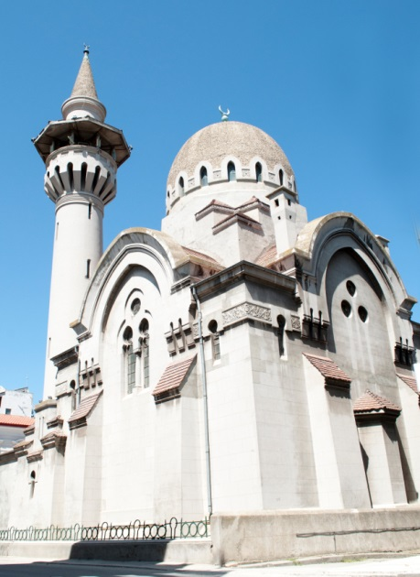
The Great Mahmudiye Mosque
Built in 1910 by King Carol I, the mosque is the seat of the Mufti, the spiritual leader of the 55,000 Muslims (Turks and Tatars by origin) who live along the coast of the Dobrogea region. The building combines Byzantine and Romanian architectural elements, making it one of the most distinctive mosques in the area. The centerpiece of the interior is a large Persian carpet, a gift from Sultan Abdul Hamid. Woven at the Hereche Handicraft Centre in Turkey, it is one of the largest carpets in Europe, weighing 1,080 pounds. The main attraction of the mosque is the 164-ft minaret (tower) which offers a stunning view of the old downtown and harbor. Five times a day, the muezzin climbs 140 steps to the top of the minaret to call the faithful to prayer.

The Hunchiar Mosque
This mosque was the first reinforced concrete building in Romania. In time, the steel-concrete rusted; restoration of the tower and cupola was completed in 1959. Built in 1867 - 1868 by order of Sultan Abdul Azis, the mosque was constructed of sandstone taken from an Ottoman bridge which had been destroyed in 1828. Having a specific moorish architecture the Hunchiar mosque is a simple structure consisting of a main body of the square, which houses a prayer hall and a 24-meter high minaret, fitted at the top with a patio. From the minaret, is the call to prayer. In the past, the imam, goes on top of the minaret to announce the believers, in Arabic dialect, it's time to pray, up to 5 times a day. Even today you can hear the call of the imam, speaking in Arabic,from the Hunchiar mosque's minaret. The only difference is that the imam not climb the minaret porch, but the speaker is used to spread the call to prayer.
During the Second World War the Hunchiar mosque was seriously damaged, which led to its closure. The church remained in this state until 1990 when representatives of the Muslim religion were renovating it. There can still be seen pieces of white stone that make up the defense wall of Constanta.
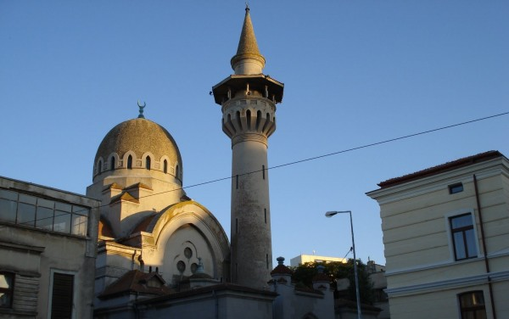

Azizyie Mosque – Tulcea
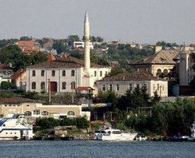
The Mosque was built in 1863, during the reign of sultan Abdul Aziz, to whom it was dedicated and from where it takes its name. It is one of the biggest mosques built by the Ottoman Empire in the territory of Dobrogea, from carved stone with a thickness of 85 cm, and has an impressive number of windows (32).
From the beginning, inside the building of the Mosques there was a Turkish school located. The minaret which we can see today dates from 1897, when it was reconstructed from funds made available by the Ministry of Culture and Public Education.

USEFULL INFO
General emergency phone number: 112
Health
No immunizations or unusual health precautions are necessary. Romania has no infectious risks and there are no poisonous insects. There is no malaria in Romania. During the summer months there are mosquitoes in the Danube Delta and some low-lying regions. For your comfort take some mosquito repellent when traveling during summer season. Tap water is safe to drink but if you are in doubt buy bottled water. Romania is home to more than 1/3 of the natural mineral springs in Europe. Bottled water is inexpensive and widely available. Some Romanian bottled water is rated the best in the world for purity and taste and is exported to many foreign countries. Naturally, we hope that you will never need to use any medical facilities. However, Romania has good medical facilities and Romanian doctors are known for their high standard of medical education.
Disabled visitors
Access for people with disabilities to Romania's tourist attractions has improved in recent years, and it remains a priority. However, it is advisable to check with all service providers prior to your visit, ensuring that they are able to meet your particular needs. Advance notice and reservations will also help ensure that you receive the best possible assistance.
Electricity
Electrical current is 220 V; 50 cycles.
Outlets take plugs with two round prongs. A plug & power adapter is necessary for most appliances requiring 110 V.
Travel with Pets
Documents needed to take your pet into Romania include a Veterinary Health Certificate and a proof of rabies vaccination, not older than six months. Translation of documents is not needed if they are in English, French or German. There are no specific customs regarding pets. Pets are allowed on trains and buses. However, large dogs must wear a muzzle.
Each hotel or restaurant has its own pet policy. In general pets are allowed in hotels and restaurants. Hotels usually charge a little bit extra for guests bringing their pets.
Smoking
Currently smoking is not allowed on planes, on buses and on some trains. Luxury hotels have designated no-smoking floors but very few restaurants have no-smoking sections. Smoking is prohibited in all public places including hospitals, concert halls, and theatres.

