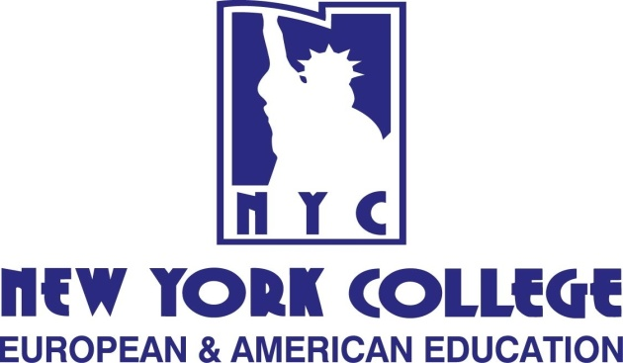

New York College (NYC) (www.nyc.gr) was founded in 1989 in Athens (Greece) and has since then expanded to Thessalonki (Greece), Prague (Czech Republic) & Tirana (Albania). NYC offers high quality and challenging undergraduate and postgraduate education, in cooperation with accredited universities in the U.S.A. and Europe, aiming at equipping students with the knowledge and skills necessary for making a significant contribution in the new globalized labor market.
We offer flexible study programs which address the needs of both non-working and working students and young executives in partnership with the following institutions: State University of New York - Empire State College USA, University of Greenwich UK, Université Toulouse 1 Capitole France, University of Bolton UK, International University of Applied Sciences Bad Honnef, Germany.
NYC International Office welcomes, counsels, and supports international students. New York College is dedicated to helping students from more than 65 countries to achieve academic excellence and personal growth as well as offering support, programs and services to students from ethnically diverse backgrounds.
NYC Academic Advisors and College Staff is at your disposal:
Tel.: 0030 2310 889879 (Thessaloniki), 0030 210 3225961 (Athens),
Email: nycath@nyc.gr & nycth@nyc.gr

