 | UNITED FEDERATION OF TRAVEL AGENTS’ ASSOCIATIONS  UNION DES FEDERATIONS D’ASSOCIATIONS D’AGENCES DE VOYAGES  UNION DE FEDERACIONES DE ASOCIACIONES DE AGENCIAS DE VIAJES  57, rue Grimaldi – MC 98000 MONACO (Principality of Monaco)  Tel : +377 92 05 28 29 □ www.uftaa.org  Emails : support@uftaa.org; ceo@uftaa.travel

UFTAA GOLDEN JUBILEE CONGRESS
1966-2016

25th & 26th November, 2016
Hilton Bosphorus : Istanbul, Turkey

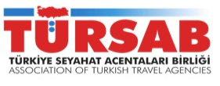
Hosts
UFTAA’s GOLDEN JUBILEE CONGRESS
A great opportunity indeed!

Supported by

Hosts : Gala Dinner  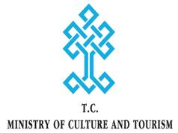 | Sponsors : Air Tickets  

An earnest invitation to join

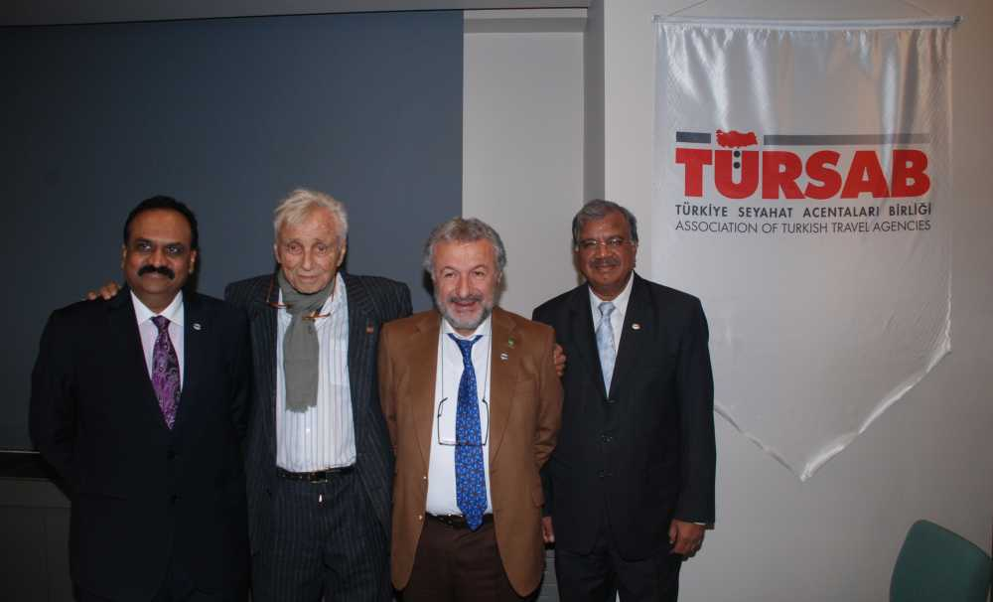 | From the Office of  Nihat Boyutzun  Hon. Board Member, UFTAA  Hon. Chairman, HOST Committee  UFTAA Golden Jubilee Congress

To : All Members of TURSAB / Industry Leaders in TURKEY
Subject : Invitation to join UFTAA GOLDEN JUBILEE CONGRESS at ISTANBUL

Dear Leader,
I am so delighted that UFTAA Golden Jubilee Congress is being held at our most historic city, ISTANBUL, on the 25th & 26th November, 2016.

It has been my life’s ambition and dream that UFTAA must have its Golden Jubilee celebrated in Istanbul. I am thankful to the UFTAA Board for honouring this invitation from TURSAB and organizing the UFTAA’s prestigious congress in Istanbul.

UFTAA is a premier federation in Travel & Tourism in the world. One can imagine the strength of UFTAA having existed successfully for 50 years.

Prominent industry leaders and association heads from various parts of the world will be in Istanbul for the Congress. TURSAB, under the able leadership of President Mr Basran Ulusoy, has taken the lead to organize a befitting Congress for UFTAA. We are well supported by Minsitry of Culture & Tourism as well as Turkish Airlines

When the world has decided to come to ISTANBUL, it is but our duty to join the GOLDEN JUBILEE Congress. I earnestly appeal to as many members of TURSAB and industry leaders from Turkey to register for the Congress. The registration fee is only EURO 300 and it is a great opportunity to network. Let us strongly reflect that TURSAB and TURKEY are ready for the world and we are thrilled to have UFTAA with us. This news of the Congress is very valuable for Turkey and its global image.
The registration form is attached and I would request you to kindly register. I would like to personally meet you at this Congress, which is my important goal in Life
Thanking you in anticipation

Nihat Boyutzun
Hon. Chairman, HOST COMMITTEE, UFTAA GOLDEN JUBILEE CONGRESS
Hon. Board Member, UFTAA

