DESTINATION SOUTH AFRICA
Located at the southern tip of Africa, South Africa is a unique tourist destination that has diverse cultures, captivating wildlife, breath-taking landscapes, and remarkable coastlines as well as a rich cultural heritage and is home to 9 UNESCO sites.
South Africa is one of mankind’s earliest settlements, having been settled by the Australopithecus africanus, more than 3 million years ago and who are the ancestors of the SAN, a stone-age people who inhabited large areas of what was to become South Africa.
South Africa is the world’s largest producer of precious metals and is home to the deepest mines in the world at more than 3 700 metres. South Africa also has the “Big Five” – elephant, lion, leopard, rhinoceros and buffalo; the “Sea Big Five” – Right Whale, Great White Shark, endangered Bottlenose Dolphin, Blue Marlin and Tuna; as well as the “Little Five” – elephant shrew, ant lion, rhinoceros beetle, buffalo weaver and leopard tortoise.
South Africa has produced 9 Nobel Prize Winners (for Peace, Medicine, Literature and Chemistry) and is the only country to have an entire floral kingdom within its borders. The Cape Floral Kingdom contains the most concentrated variety of fauna, 8 500 flowers, the richest variety on earth. South Africa has 23 200 plant species, a greater variety than of the entire northern half of the planet. South Africa is also the strongest financial and industrial power in Africa and has consistently been in the top 10 as one of the world’s most transparent economies.
We encourage you to visit South Africa and experience our warm tropical climates, and the welcoming smiles of our people that make our country a holiday haven for visitors. Whether you’re looking for a tranquil experience at our safari and coastal offerings, or a bustling vibe at our township and adventure destinations, a memorable experience awaits at all our nine provinces.
Discover the origins of mankind at the Cradle of Humankind in Gauteng, which harbours evidence of the oldest hominids and ancestors of the human race. Explore the Sterkfontein Caves, Swartkrans and Kromdraai, and experience first-hand the fossil records that lie in the limestone caves.
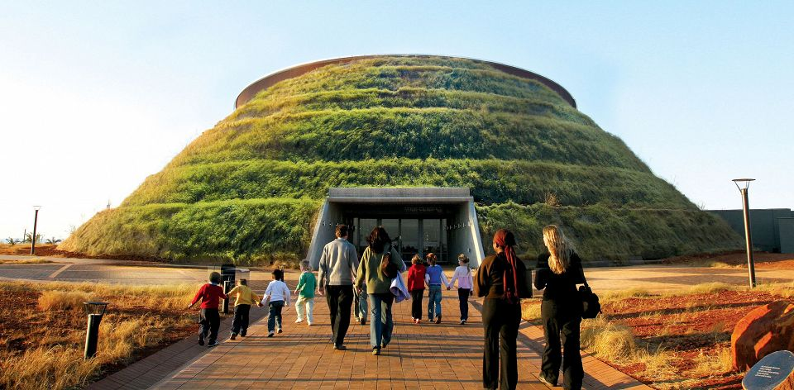

Navigate through the Kgalagadi Transfrontier Park and meet the San people in our newly inscribed cultural World heritage site, ‡Khomani. Dance under the desert night sky and experience how the San preserved their culture for over 150 000 years.
With a little over 3% of the world’s plant species blooming in South Africa, nature enthusiasts can take in the breath-taking beauty of our natural parks at the Cape Floral Region, the Panorama route, iSimangaliso Wetland Park and the uKhahlamba Drakensberg Park.
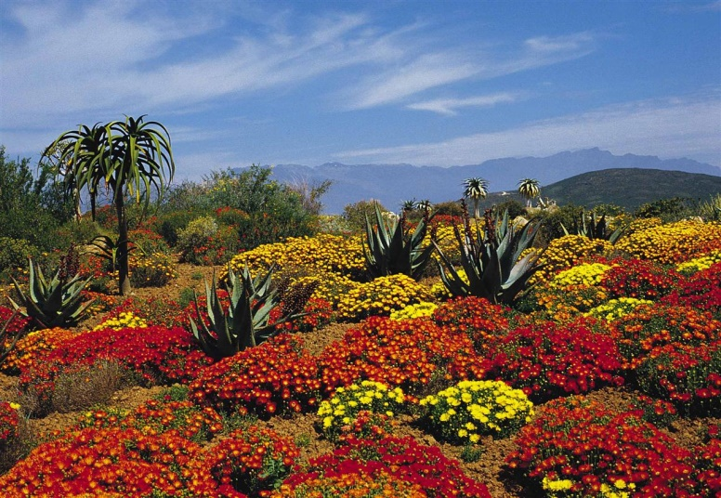
Visitors can also visit the largest, and one of the oldest known meteor impact sites at the Vredefort Dome.
Experience South Africa's wildlife through an adrenalin-filled safari at Kruger National Park. It is the largest game reserve on the continent and boasts more species of mammals than any other African game reserve.
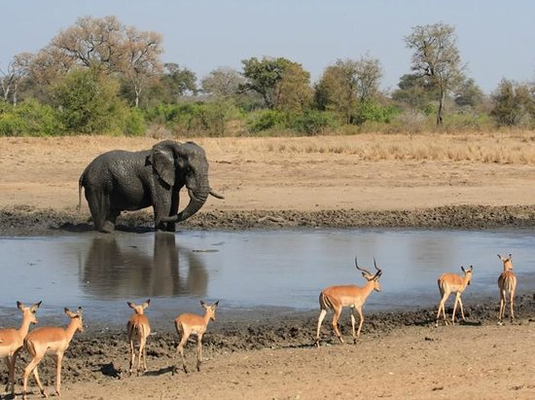
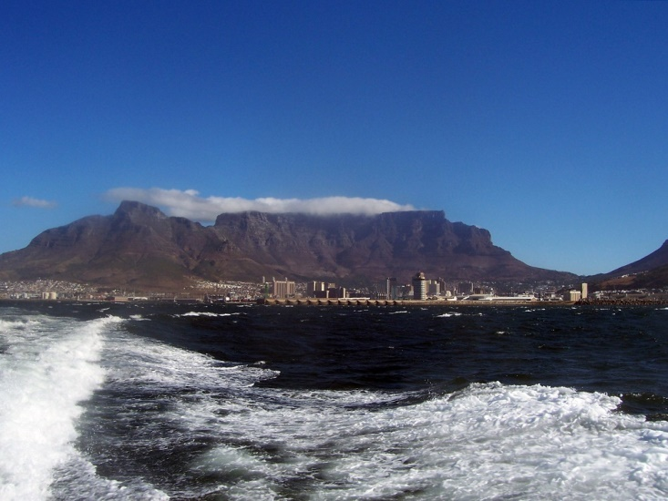
At the top of one of the World’s Seventh Wonder – Table Mountain – visitors can get an aerial view of Robben Island, which has become a historical symbol of freedom and South Africa’s triumph over oppression. A ferry ride will afford you an opportunity to walk through the prison walls that held South Africa’s freedom fighters and the country’s first democratically elected president – Nelson Mandela.
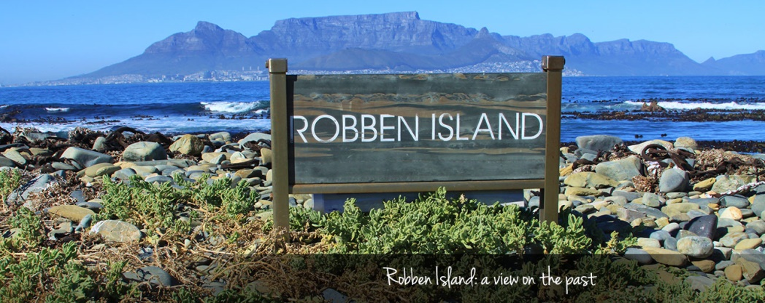
The beauty of the nature and game parks, the authentic cultural and heritage experiences, and the warmth of the people makes South Africa a holiday destination of choice.

