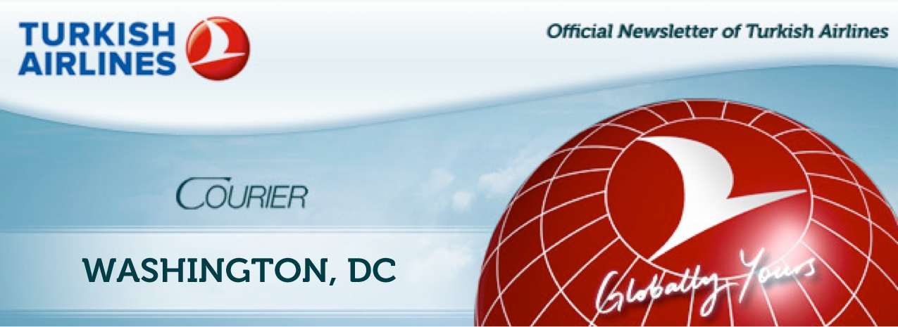
WASHINGTON SALES OFFICE  ISSUE DATE: NOV 4, 2011  TICKET SALES PERIOD: NOV 05 -15, 2011  TRAVEL DATES PERIOD: JAN 10,2012, MAR 20,2012 | WINTER 2011 ECONOMY SPECIALS  G- CLASS  ISTANBUL TO WASHINGTON
SPECICIAL OFFER FOR LIMITED TIME ONLY
IST – IAD - IST | GPX3M// 299.00 EUR
CATEGORY | PROVISIONS
RBD | G
ADV RES./  TICKETING | RESERVATIONS ARE REQUIRED FOR ALL SECTORS. TICKETING MUST COMPLETED WITHIN 72 HOURS AFTER AFTER RESERVATIONS ARE MADE.
MIN./ MAX. STAY | MIN: SU MAX: 3M
STOPPOVER | LIMITED 1 FREE, 1 AT EUR 40.00 IN ISTANBUL
COMBINATIONS | FARES MAY BE COMBINED ON A HALF ROUND TRIP BASIS WITH TK FARES IN SAME TARIFF. DOMESTIC US AND TR ADD-ON`S PERMITTED.
SALES RESTRICTION | TICKETS MUST BE ISSUED ON/AFTER NOV 05, 2011 AND ON/BEFORE NOV 15,2011
TRANSFERS | 6 FREE TRANSFERS PERMITTED ON THE PRICING UNIT - 3 IN EACH
PENALTIES | REBOOKING : 150 EUR  NO-SHOW : 300 EUR  REFUNDS: NOT PERMITED EVEN MEDICAL REASONS
ENDORSEMENTS | TKT MUST BE ANNOTATED: “TK ONLY, NON-ENDORSABLE”
CHD/INF DISCOUNTS | CHD: NO DISCOUNT,  INF. (WITHOUT SEAT): MUST PAY %10 OF THE FARE
FREE BAGGAGE ALLOWANCE | 2PC ( 50LB EACH )

